**SERVED AS RESOURCE PERSON / GUEST**

1. **“WOMEN ARE THE ARCHITECTS OF SOCIETY”** addressed as a Chief guest for the International Womens day Celebration “on 06.03.2020.

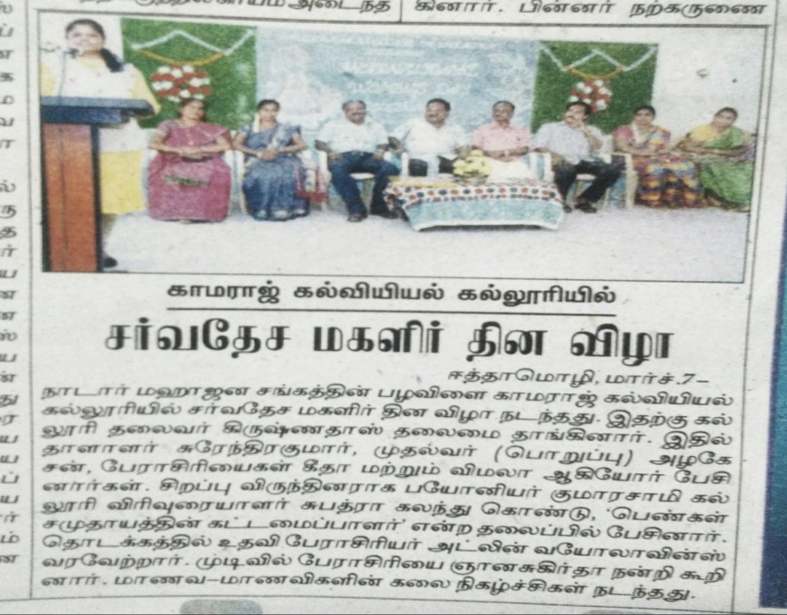

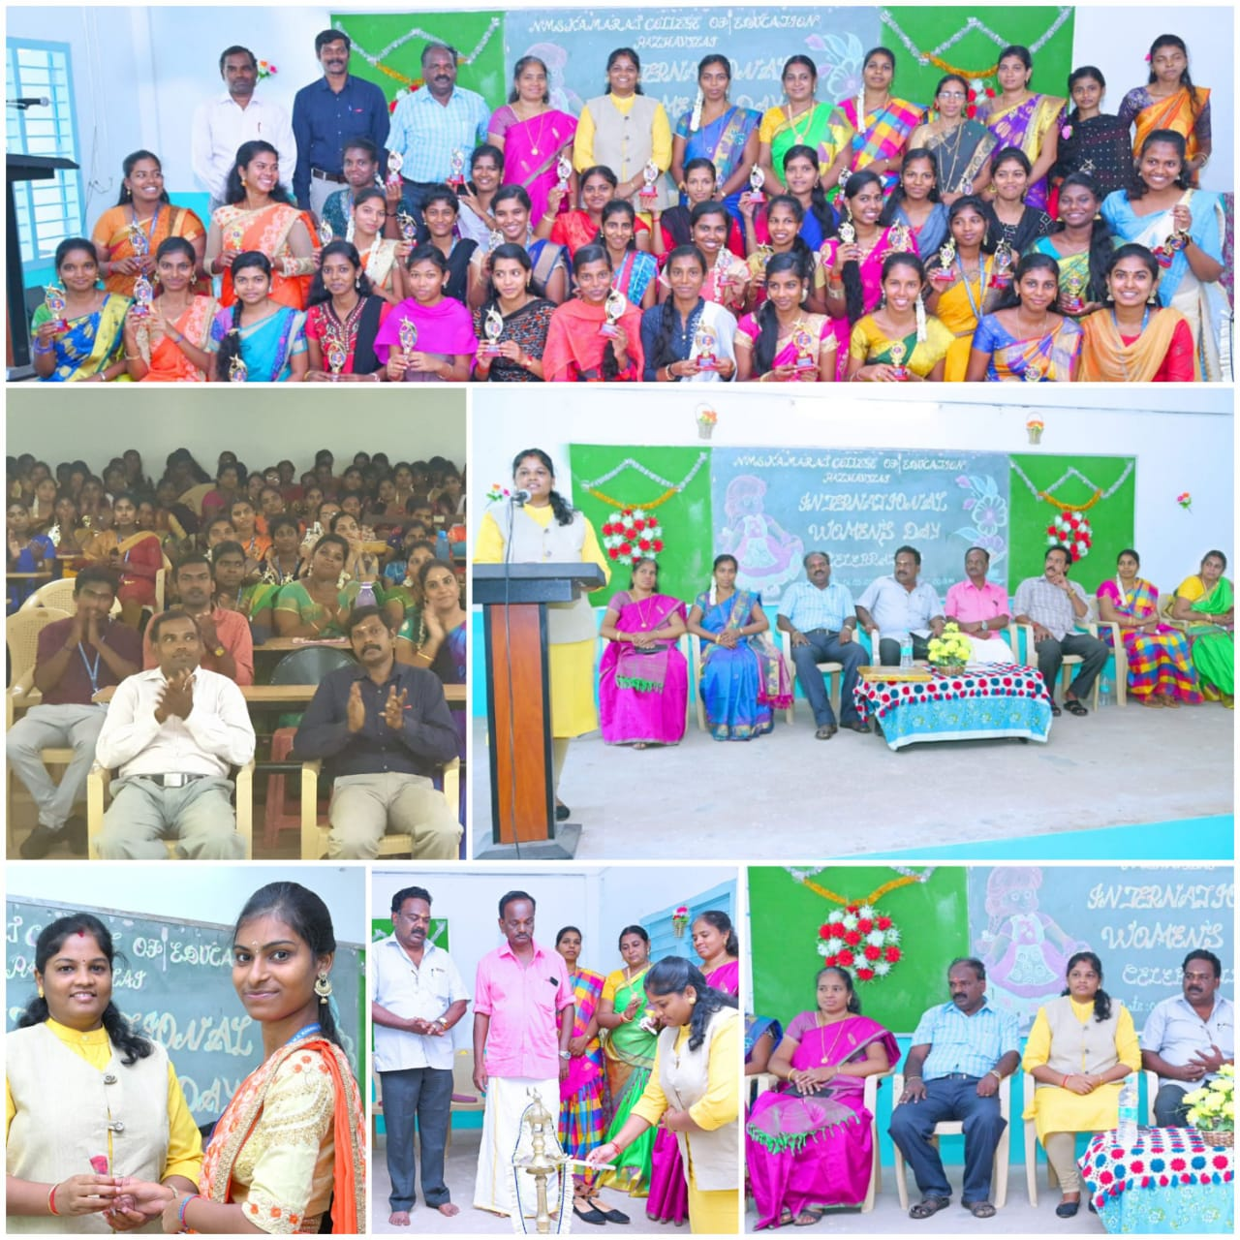

1. **“TRENDING FRONTIERS AND PROSPECTS IN COMMERCE AND MANAGEMENT” served as the Chair person for the** International Conference at Department of Commerce, Women’s Christian College, Nagercoil on 04.30.2020.

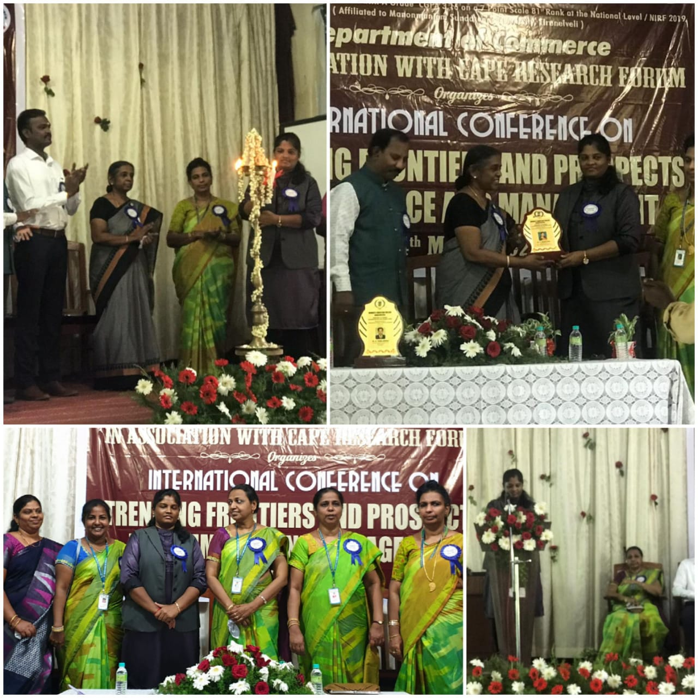

1. **“PROSPECTS AND HORIZONS IN COMMERCE AND MANAGEMENT”,** served as the Chair person for theTwo day International Conference on organized by PG and Research Department of Commerce, St.Jude’s College , Thoothoor on 05 & 06.03.2020.

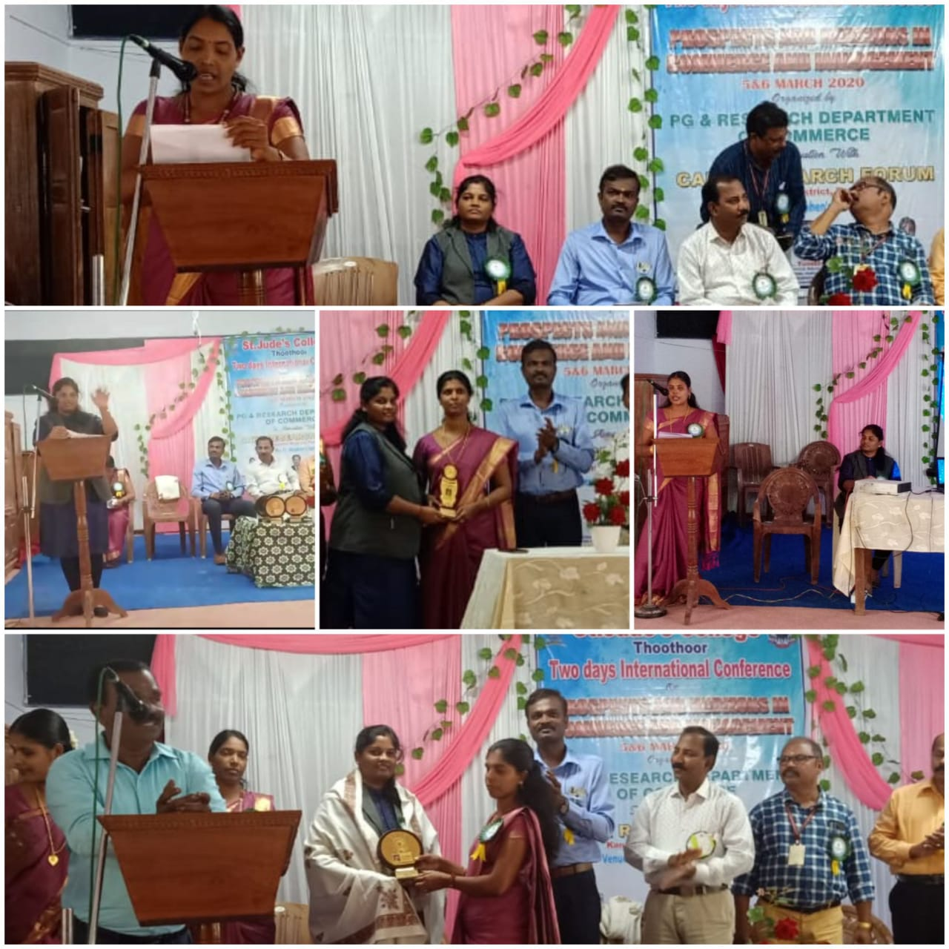

1. **“My GOOD COMPANION – T”** Technical Session as a Chief guest cum Resource Person for the Commerce Association Meeting at Department of Commerce, St.Judes College, Thoothoor on 19.02.2020. (FN).

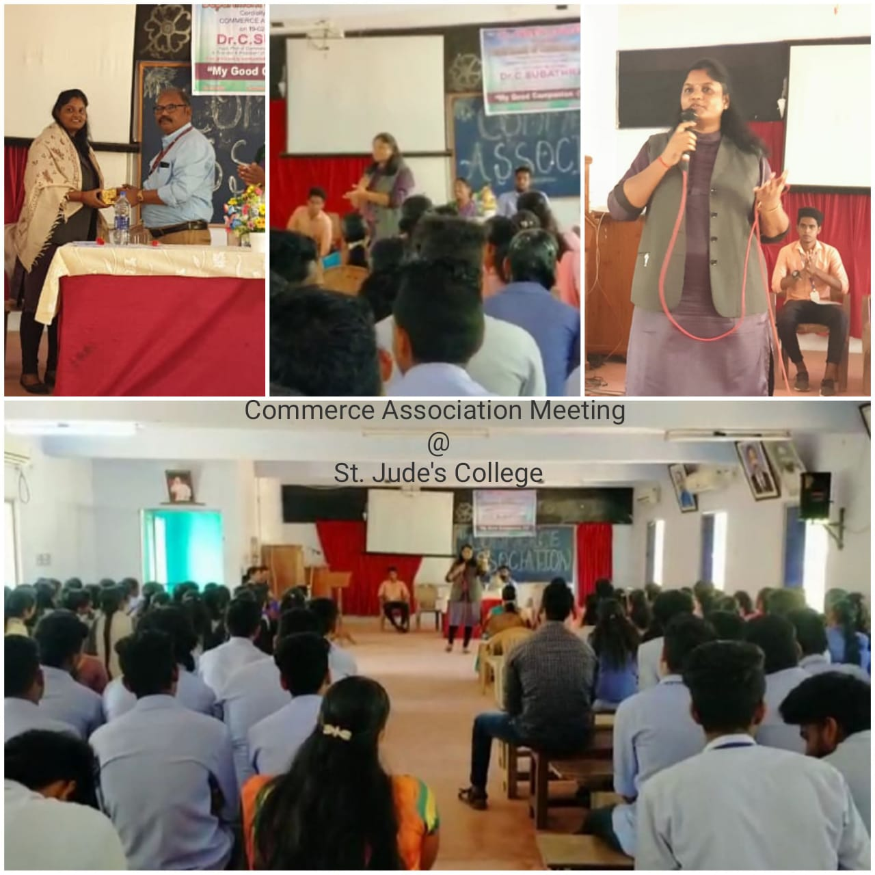

1. **“E – LEARNING AND DEVELOPMENT”** , Technical Session as a Chief guest cum Resource Person for the Workshop on ICT in Teaching , Learning and Development at Lord Jegannath College of Education , Ramanatheechanputhur on 19.02.2020. (AN).

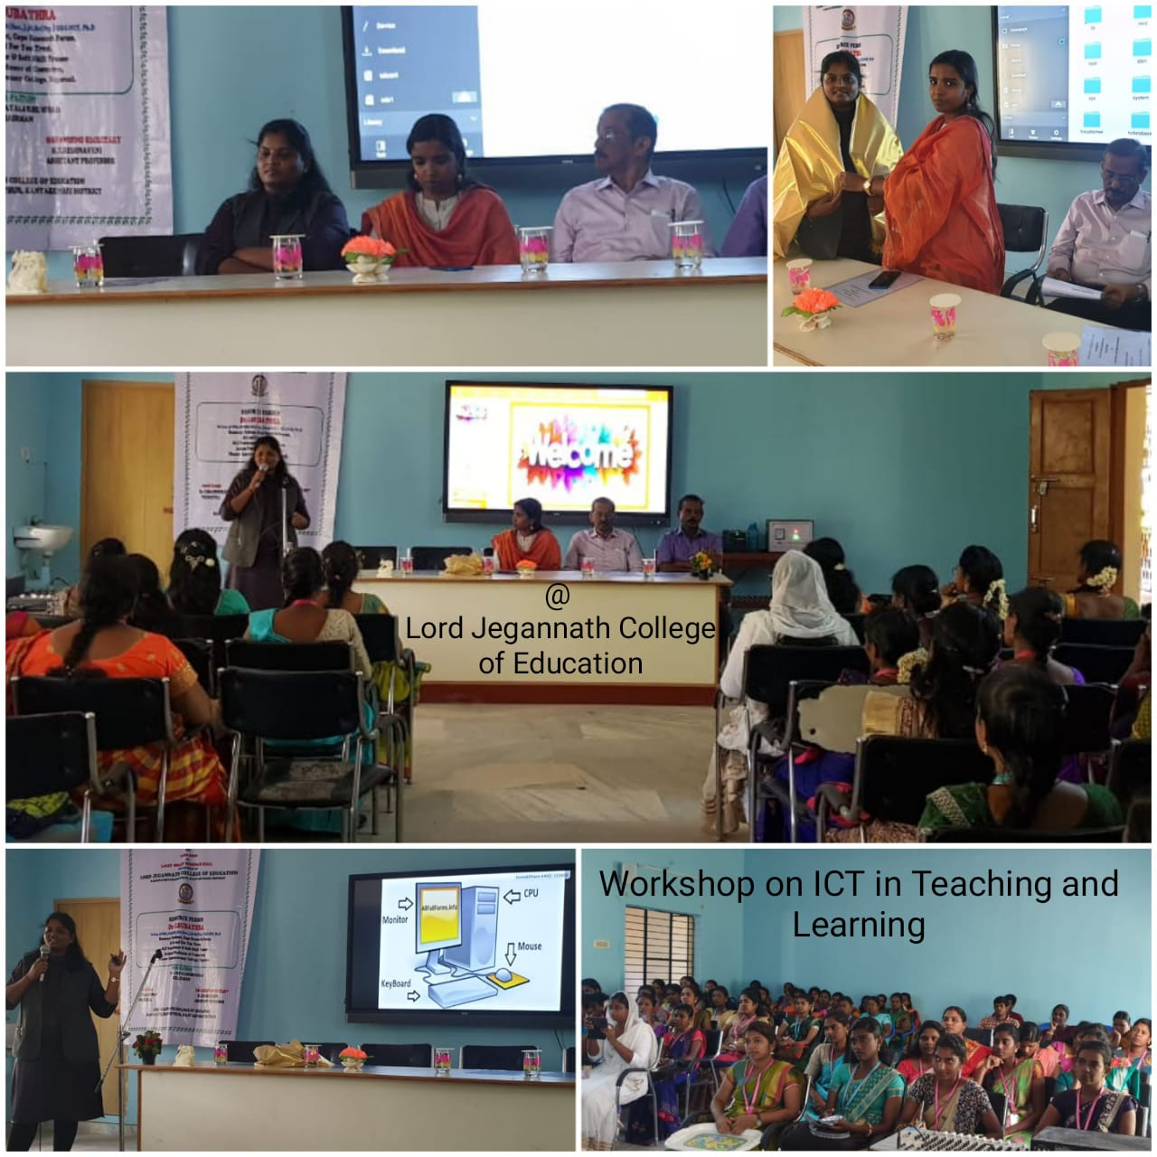

1. **“INNOVATE AND EMERGE AS AN ENTREPRENEUR”** for the Seminar on Entrepreneurship for the Commerce Students at Womens Christian College, Nagercoil , served as a Resource person and delivered a Technical Session on 14.02.2020

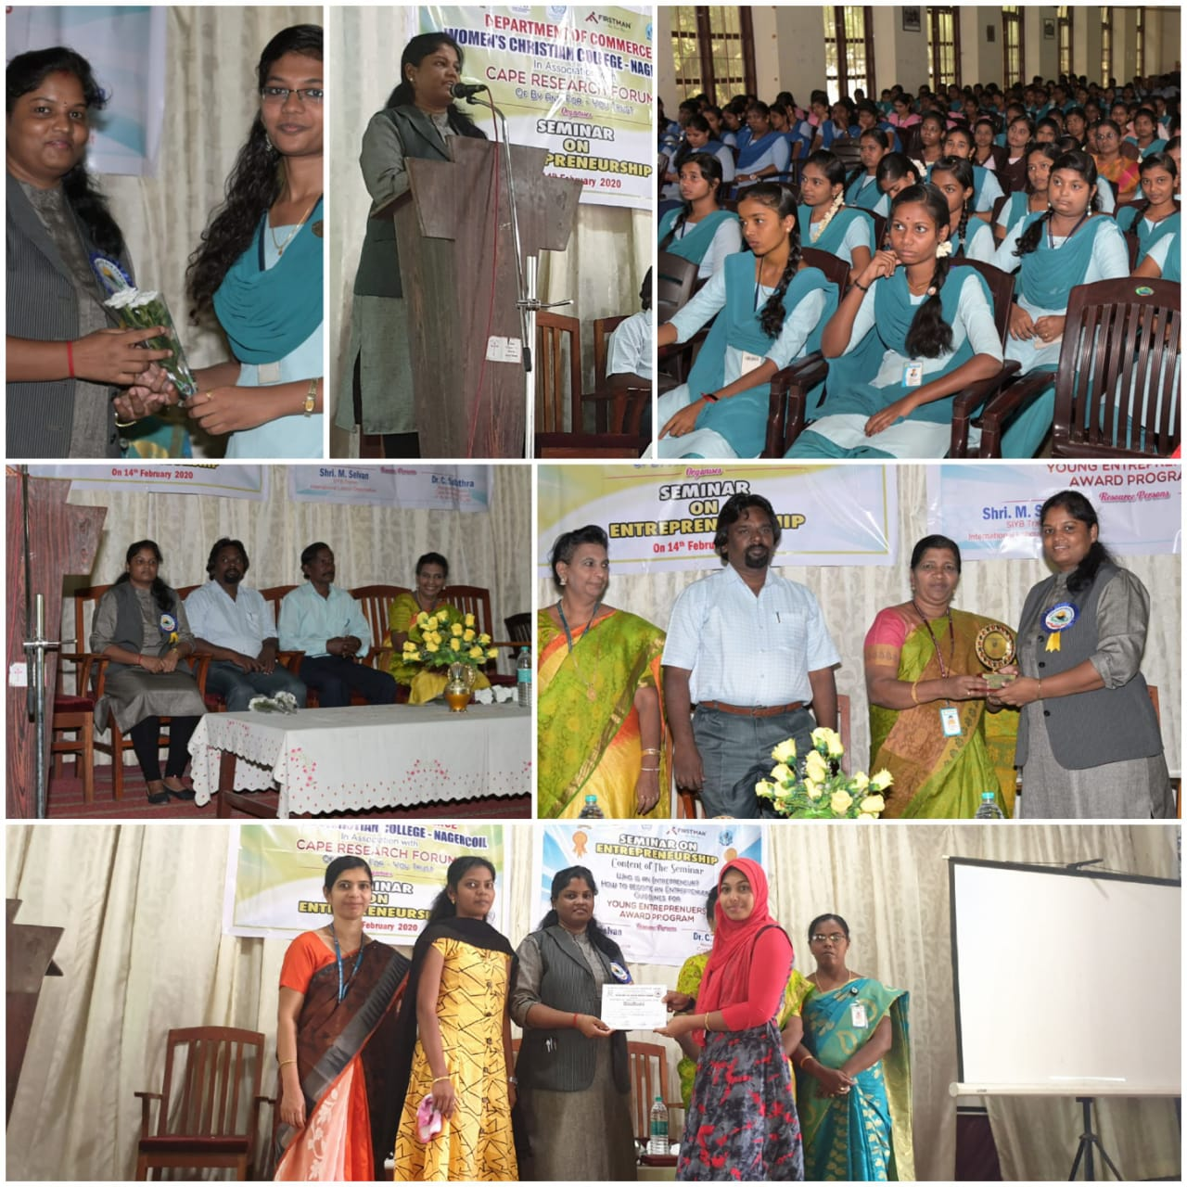

1. **“QUALITIES OF A SUCCESFUL PERSONALITY ”,** a talk and interactive session for the “Youth Club development Training” for the volunteers of Nehru Yuva Kendra Sangathan at NYKS Building, Kanyakumari on 18.01.2020.

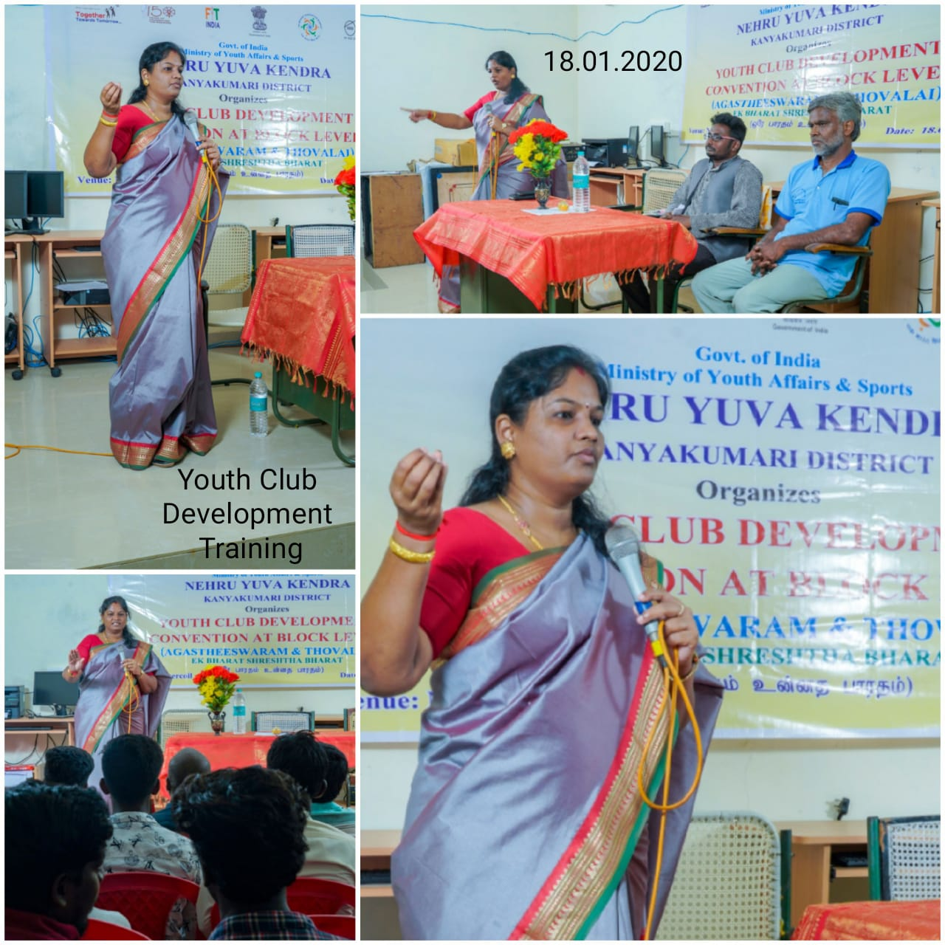

1. **“OPPORTUNITIES FOR YOUTH IN INDIA”** at Pongal Celebration @ Sivangnapuram, Tirunelveli on 15.01.2020, Distributed prizes for the Prize winners of Various Competition.

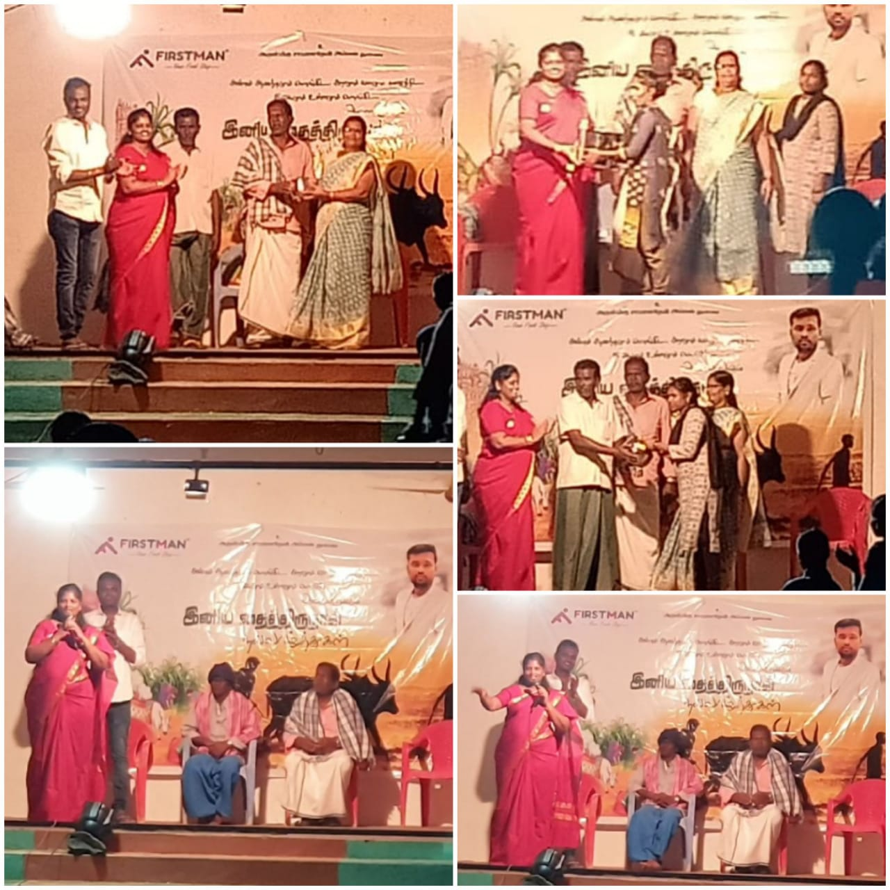

1. **“QUALITIES OF A SUCCESFUL LEADER ”,** a talk and interactive session for the “Youth camp” for the volunteers of Nehru Yuva Kendra Sangathan at Vivekanandha Kendra, Kanyakumari on 18.11.2019

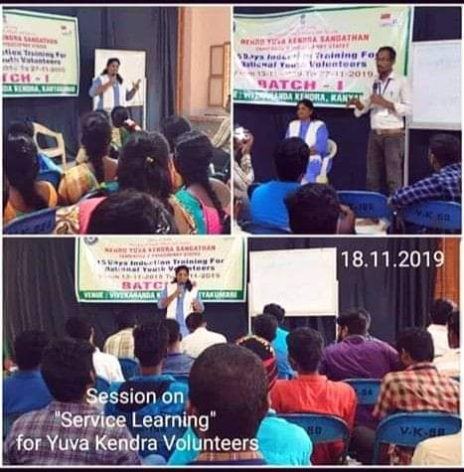

1. **“CHILDREN ARE THE TOMORROWS LEADER”** for the Childrens day Celebration and Awareness Rally for the Govt School Children at Ilanthayadi , Kanyakulam , on 14.11.2019 .

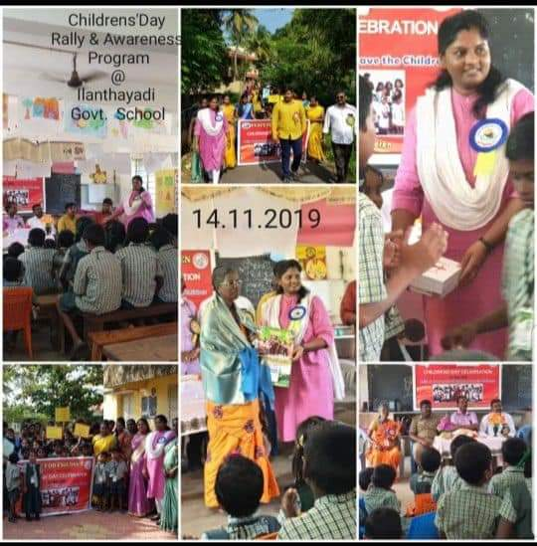

1. **“SERVICE LEARNING ”,** a talk and interactive session for the “Youth camp” for the volunteers of Nehru Yuva Kendra Sangathan at Vivekanandha Kendra, Kanyakumari on 02.11.2019

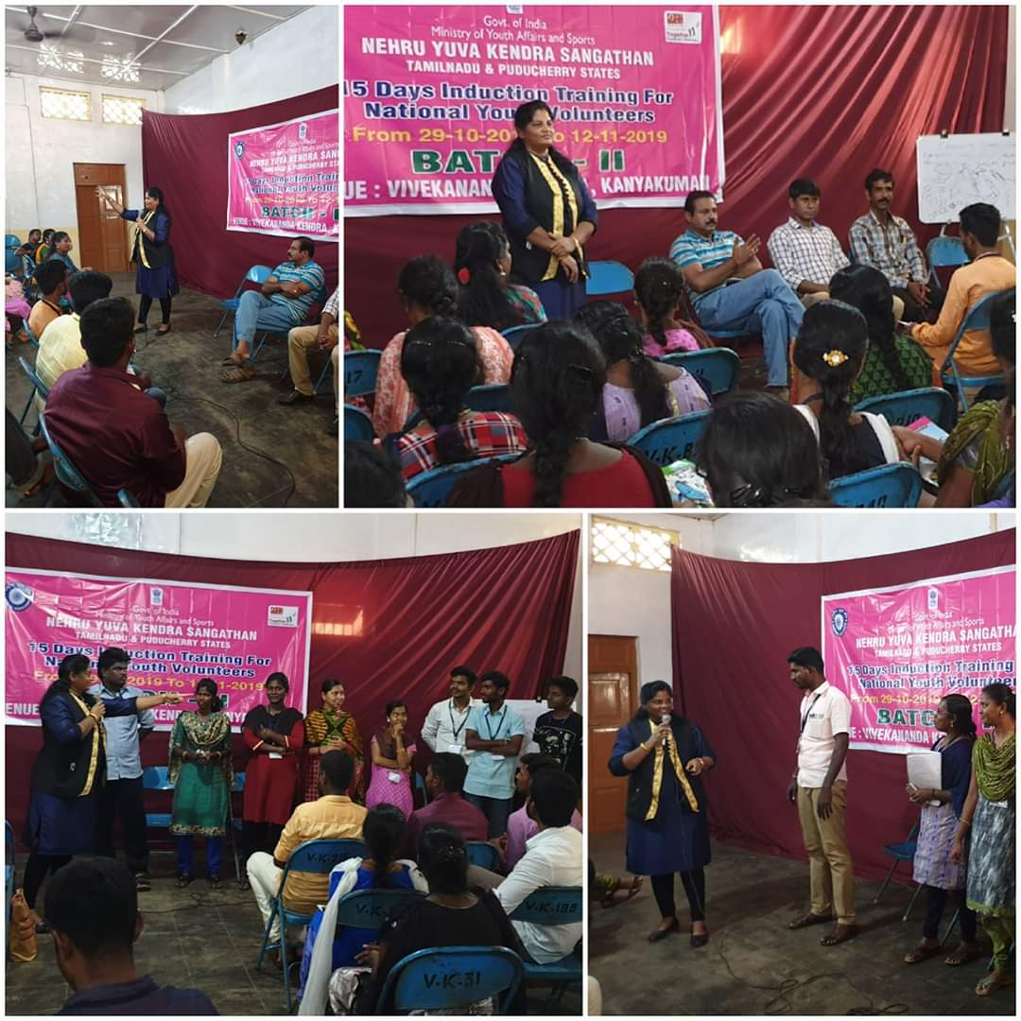

1. **“INVESTMENT AWARENESS”** for the Financial Literacy & Investment Awareness Program for Commerce students of Pioneer Kumaraswamy College, Nagercoil on 22.10.2019

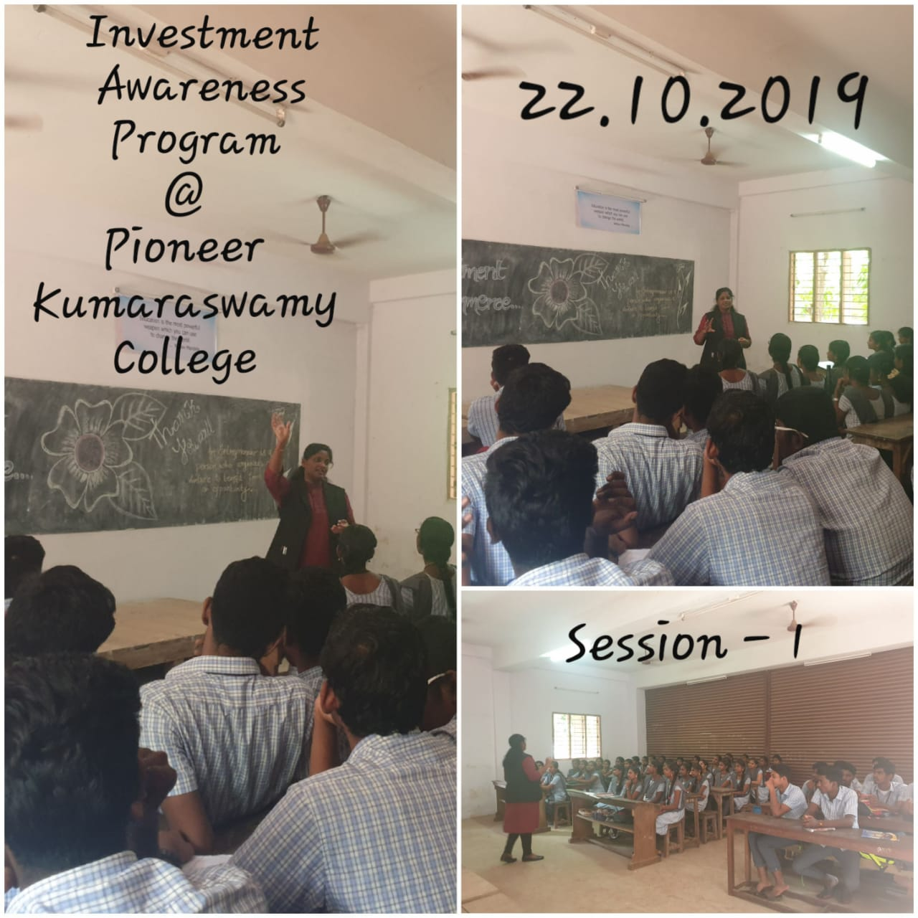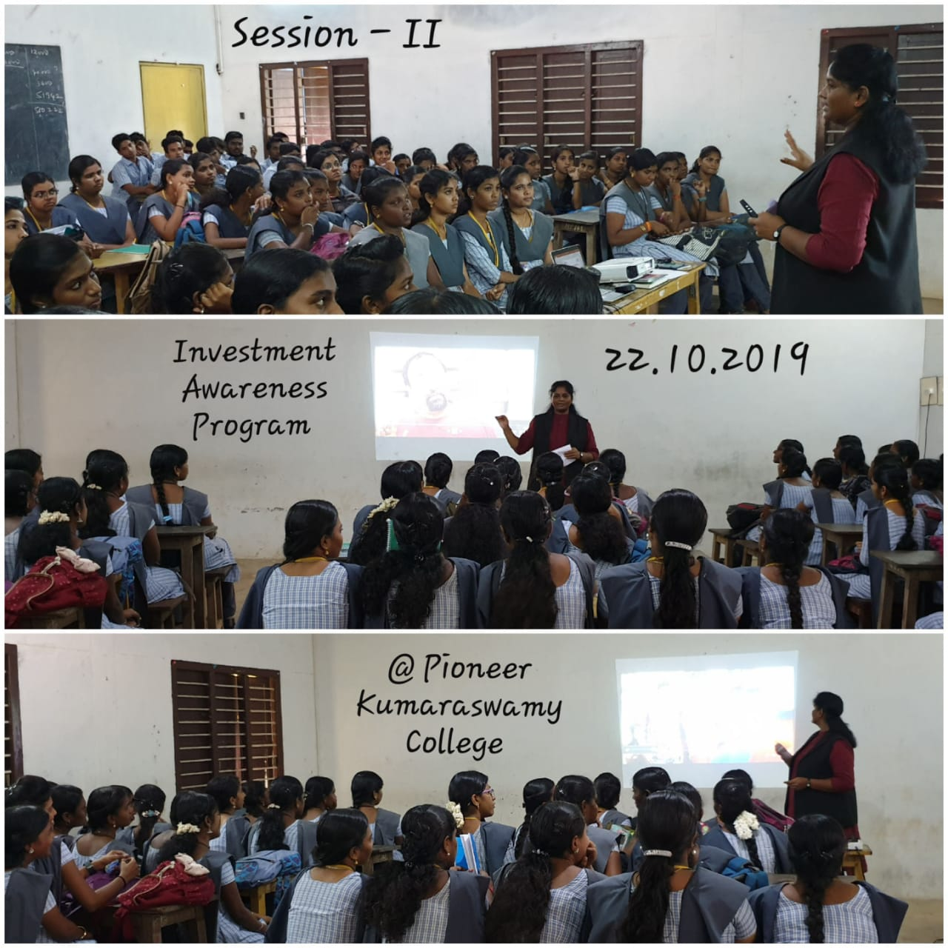

1. **“VOLUNTEERISM – A SERVICE LEARNING ”,** a talk and interactive session for the “Youth Leaderhsip Training” for the volunteers of Nehru Yuva Kendra Sangathan at Vivekanandha Kendra, Kanyakumari on 02.10.2019

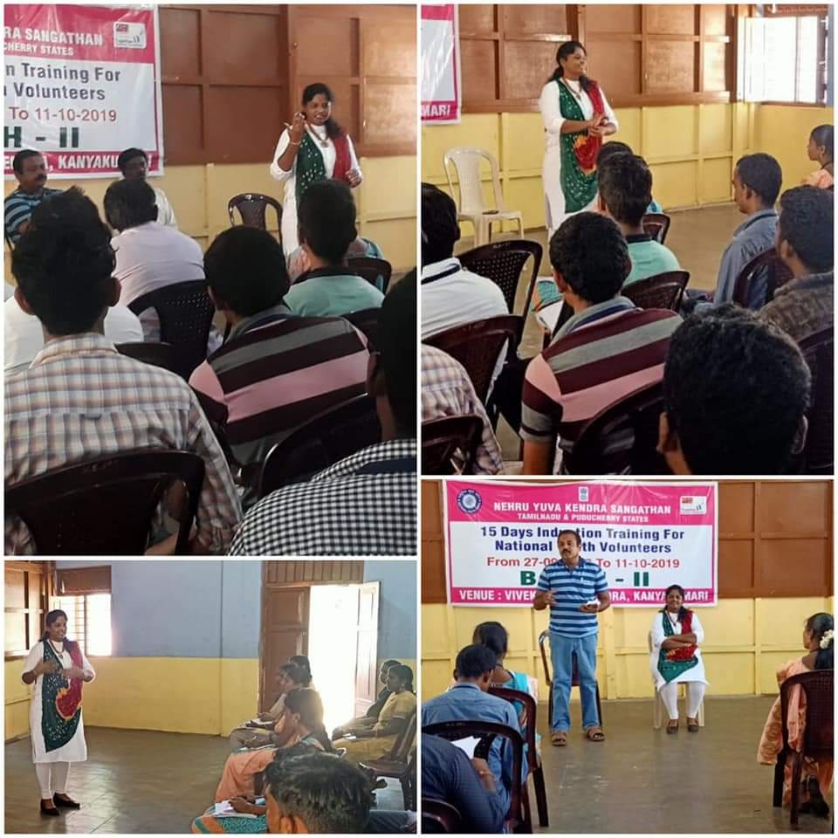

1. **“SMART STUDENTS WITH INNOVATION”** a talk as a Chief Guest for the Inauguration of Smart class at Govt. School, Manavalakurichi, Kanyakumari on 24.08.2019.

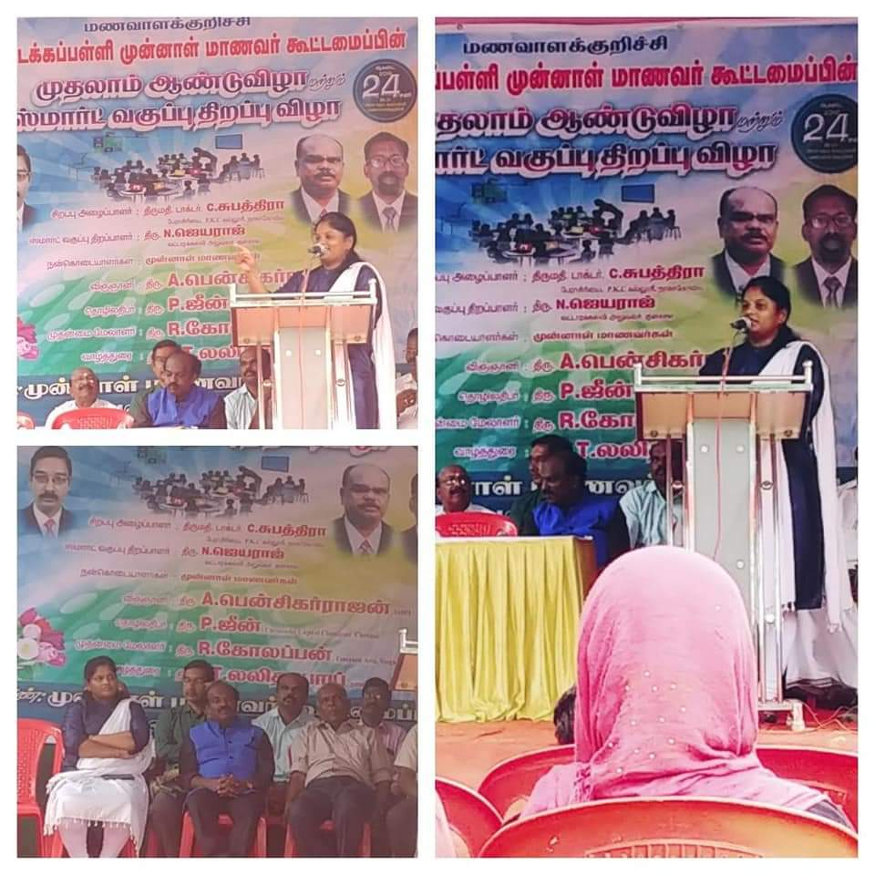

1. **“COMPETENCY WITH CHARACTER”** a lecture as a Chief Guest for the Inauguration of Commerce Association, St. Xaviour College, Palayamkottai, Tirunelveli on 11.07.2019.

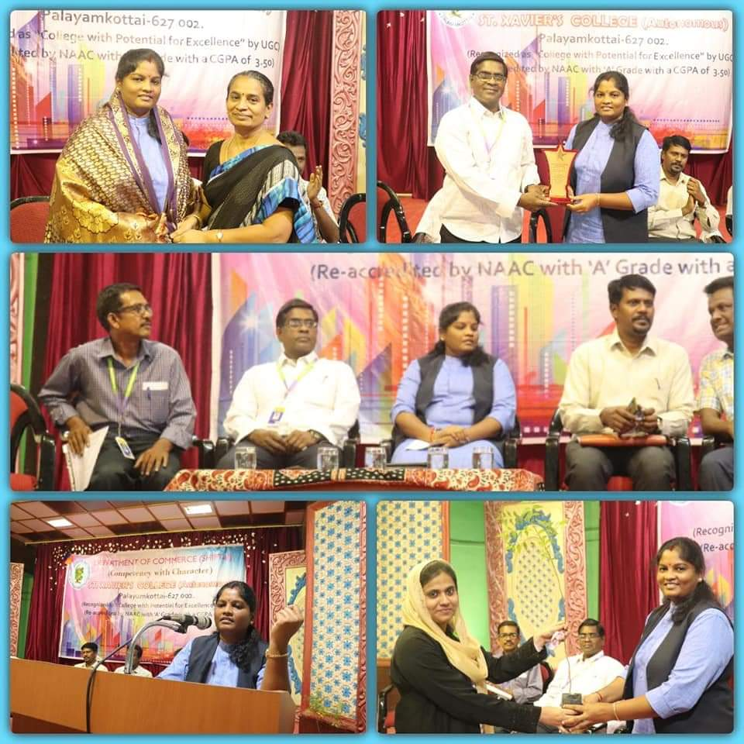

1. **“STATUS OF AGRICULTURE IN INDIA”** , for the National Seminar on **“Status of Agriculture and Livelihood of farmers – Initiatives and a Way Forward”** Organised by Vivekananda College, Agastheeswaram in Association with Cape Research Forum, Nagercoil at Vivekananda College on 28.06. 2019.

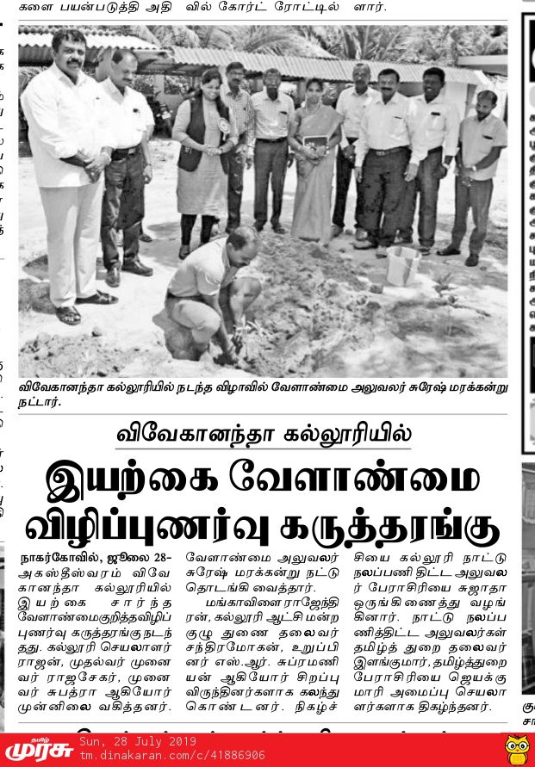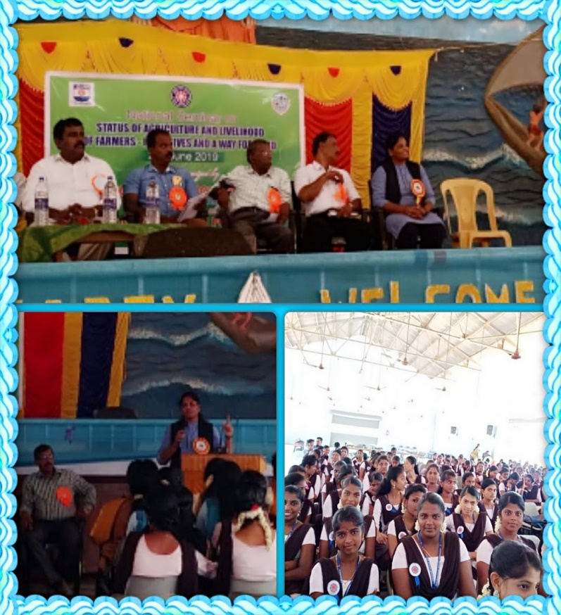

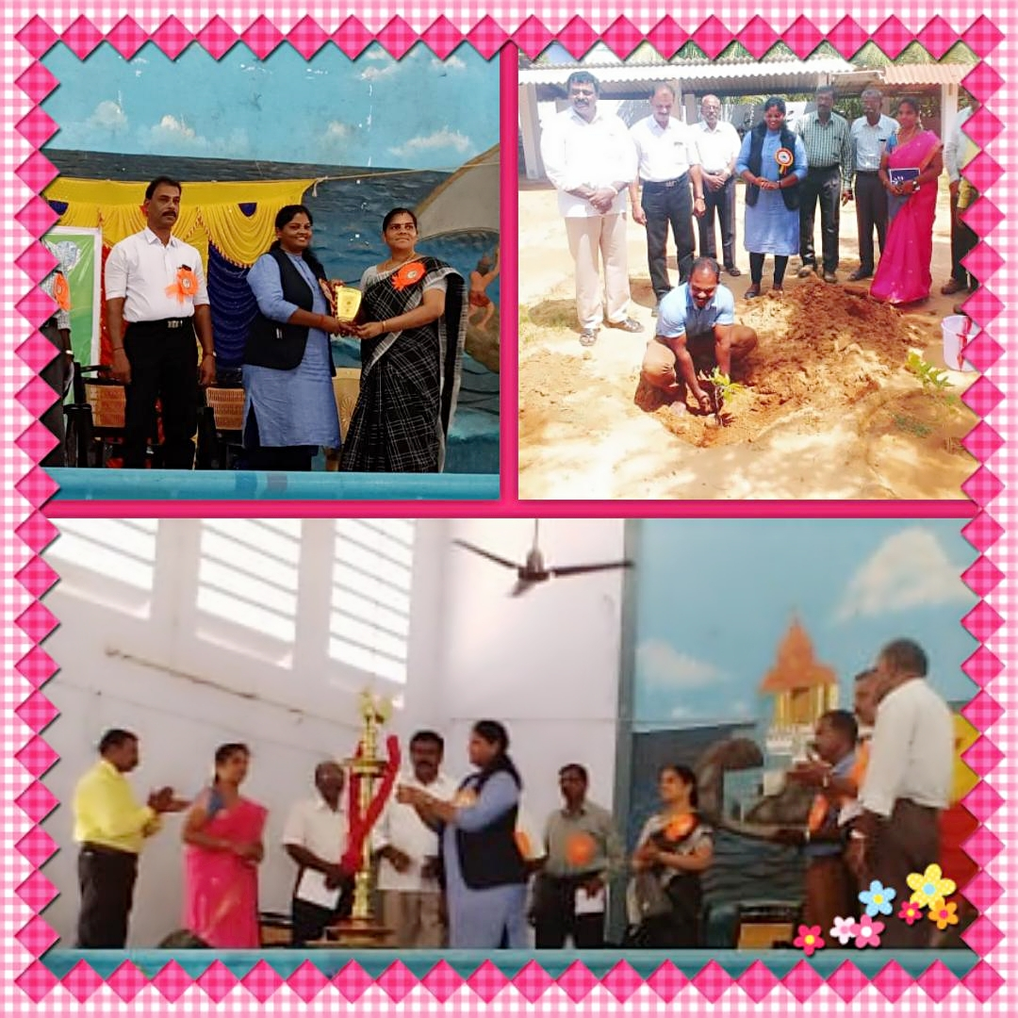

1. **“VOLUNTEERISM”** delivered a talk as the Chief Guest and Resource person for the Inauguration of Special Camp on 25.03.2019 at Ezhusattupathu, Agastheeswaram for the Vivekanadha College, NSS Volunteers.

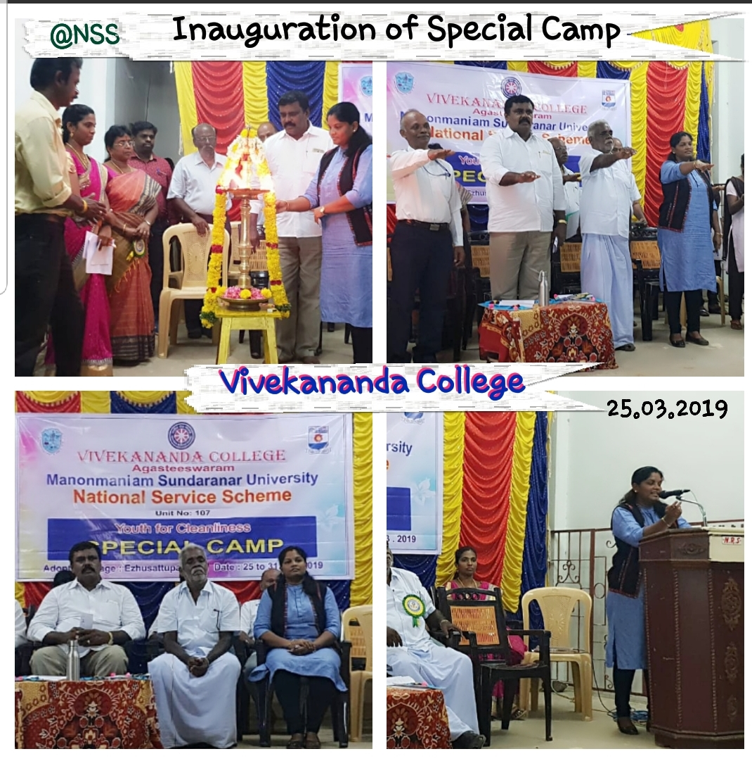

1. **"COMMERCE, MANAGEMENT AND LEADERSHIP – A GLOBAL PERSPECTIVE”** acted as theChair Person for the International Conference , Organised by Department of Commerce, Pasumpon Muthuramalinga Thevar College, Melaneelithanallur, Sankarankoil on 06.03.2019.

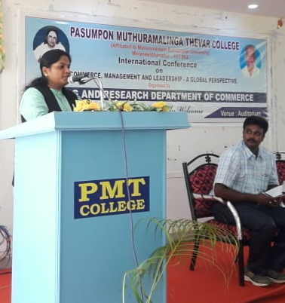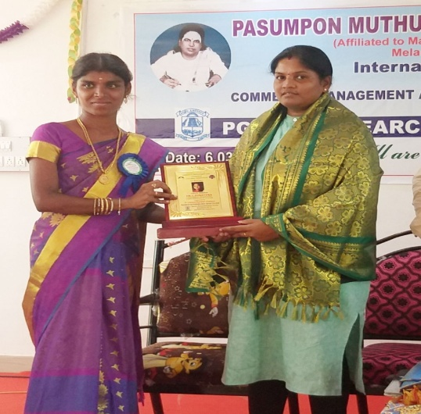

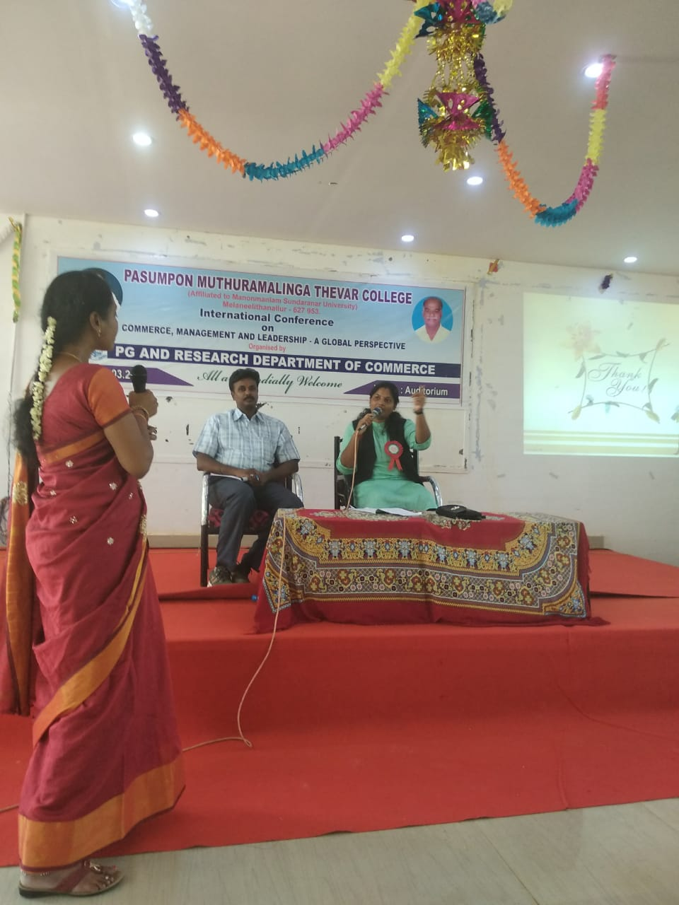

1. **ART OF WRITING ARTICLES”** for the National Workshopat Pasumpon Muthuramalinga Thevar College, Melaneelithanallur, Sankarankoil on 15.02.2019..

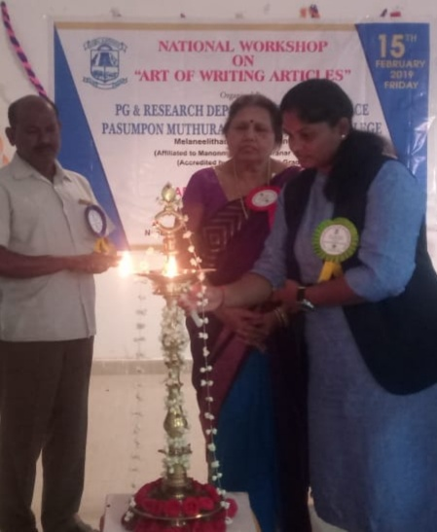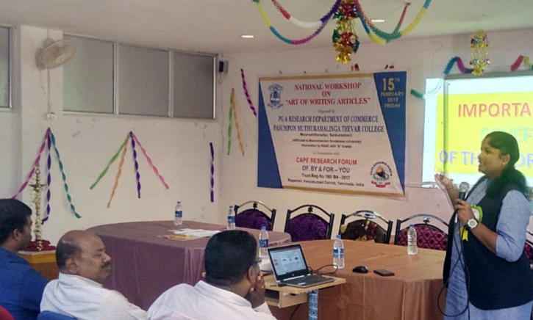

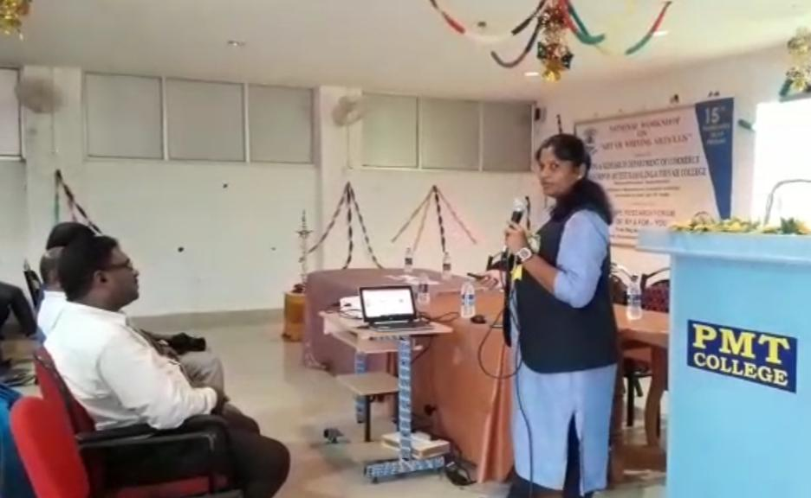

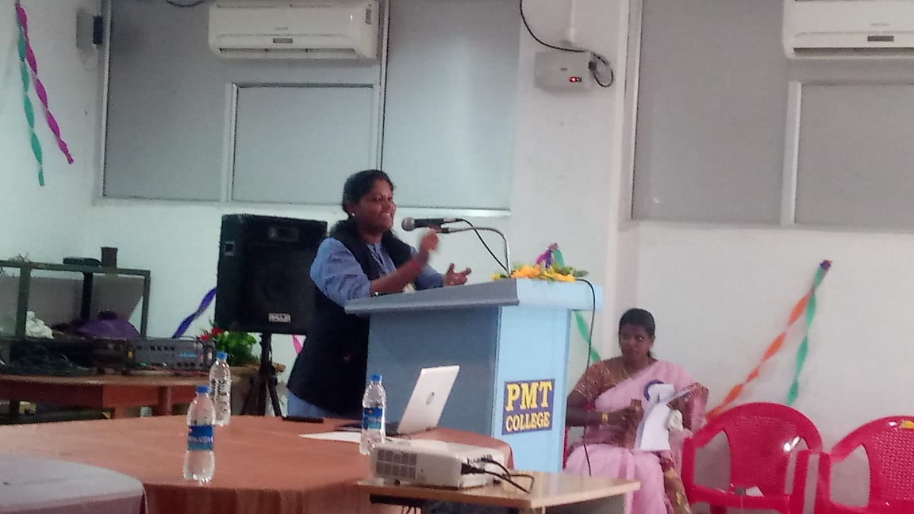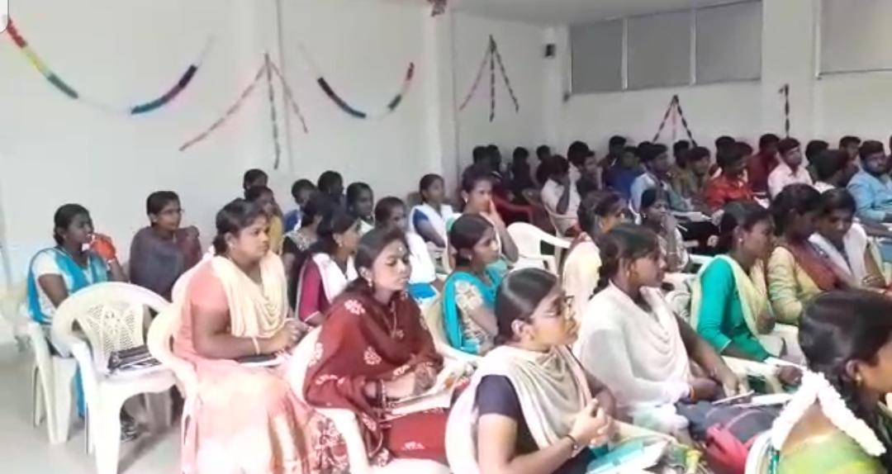

1. **“HRM – AN INVENTIVE PRACTICES”** for the National Conferenceat Muslim Arts College, Thiruvithancode on 12th Feb 2019.

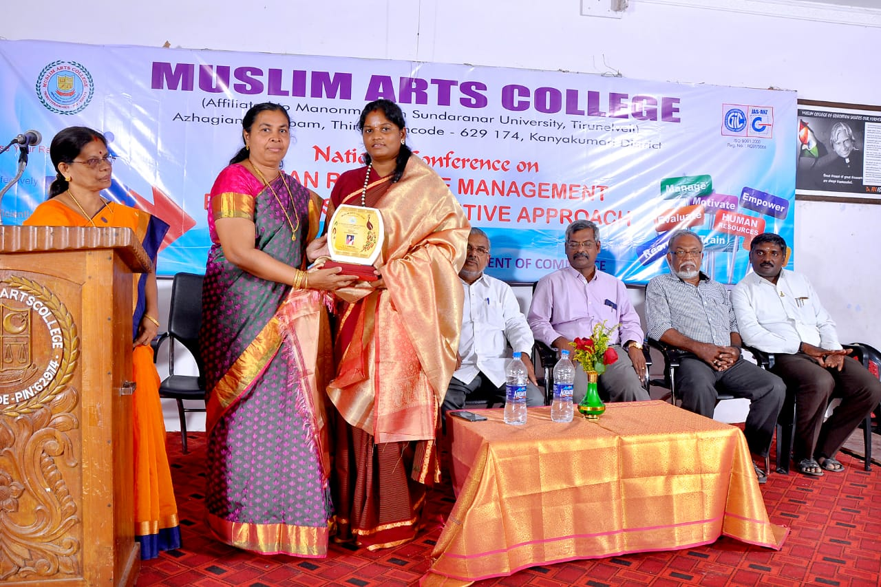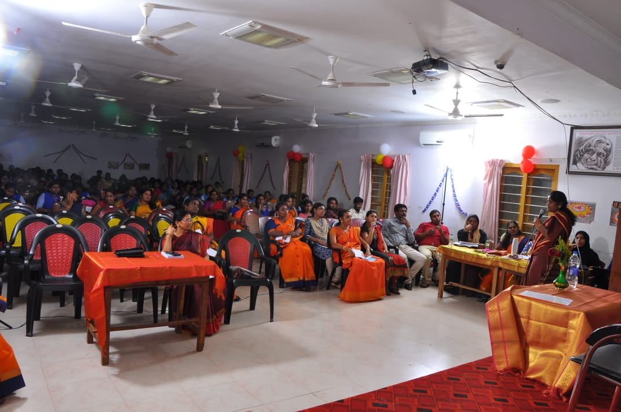

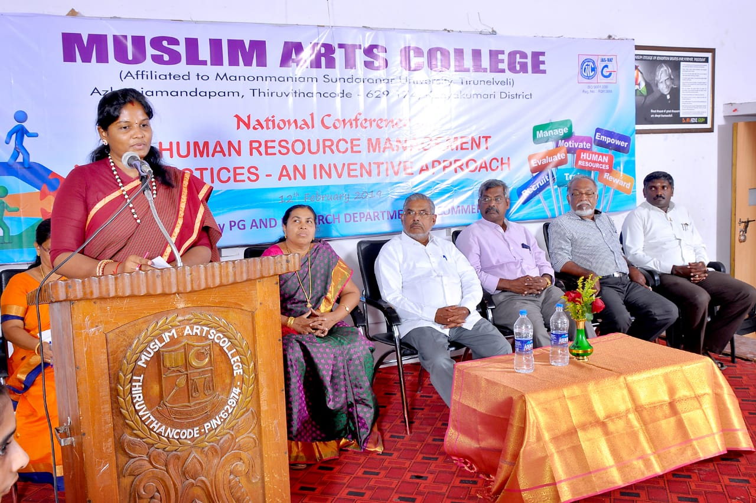

1. **“COMMERCE AND MANAGEMENT IN DIGITAL ERA” for the** One Day International Conference at Vivekanada Kendra, Kanyakumari, on 19.01.2019.

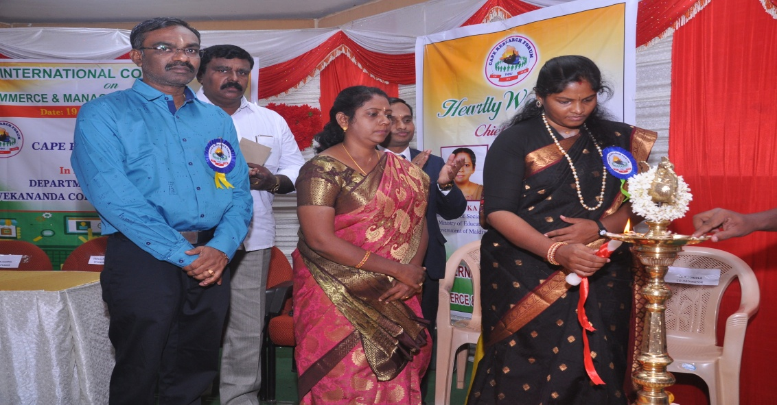

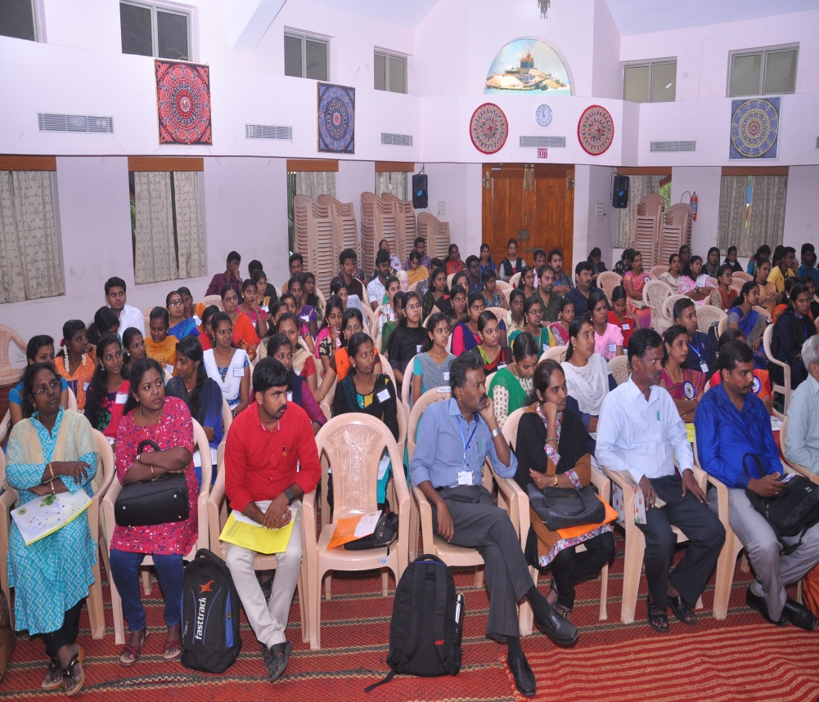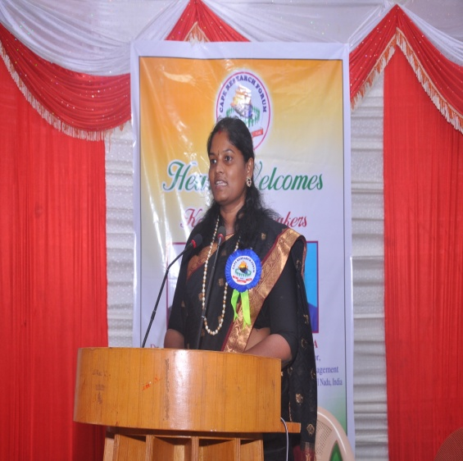

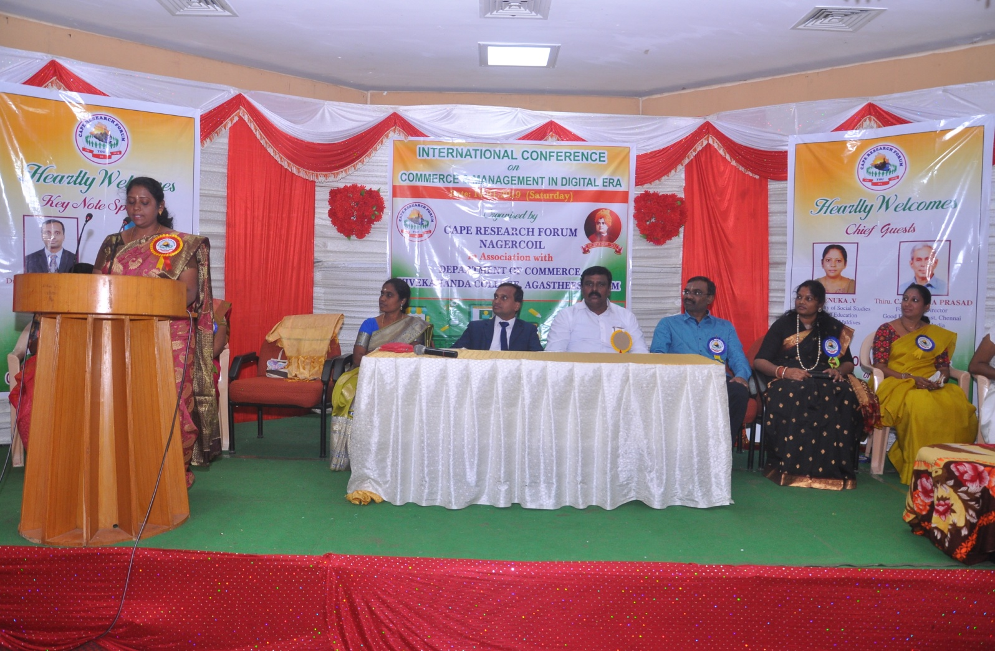

1. **“SOLVE THE UNSOLVE”** Guest Lecture for the Rotary Club of West Nagercoil, on 26.08.2019 at Rotary Community Centre, Nagercoil.

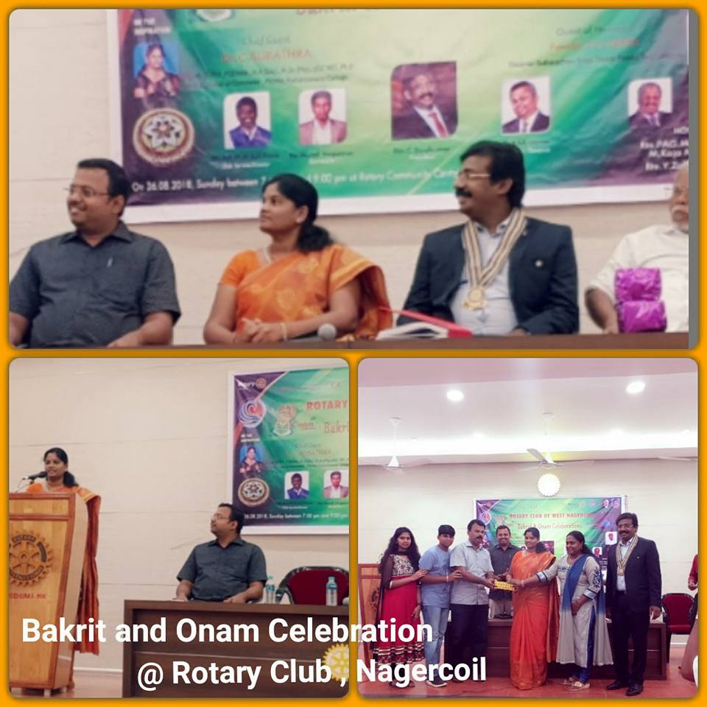

1. ONAM CELEBRATION and Deliverd a Talk on “Importance of Onam” , at Rishi Kids School, Nagercoil, Kanyakumari District on 23.08.2018

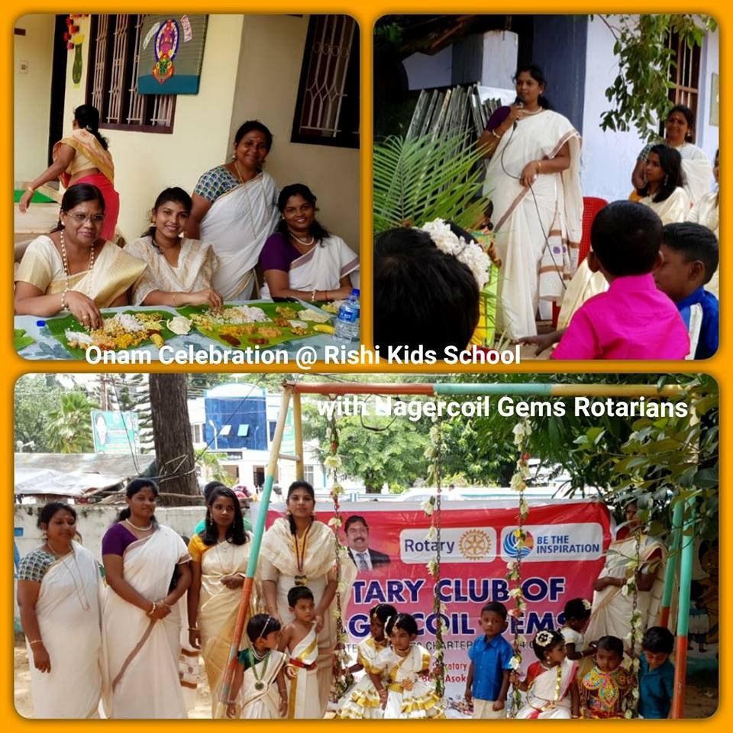

1. “**HUMAN RIGHTS AND GENDER STUDIES**” for the National Interdisciplinary Seminar, organized by Department of English and Commerce (PG), AVS College of Arts & Science, Salem on 5th March 2018.

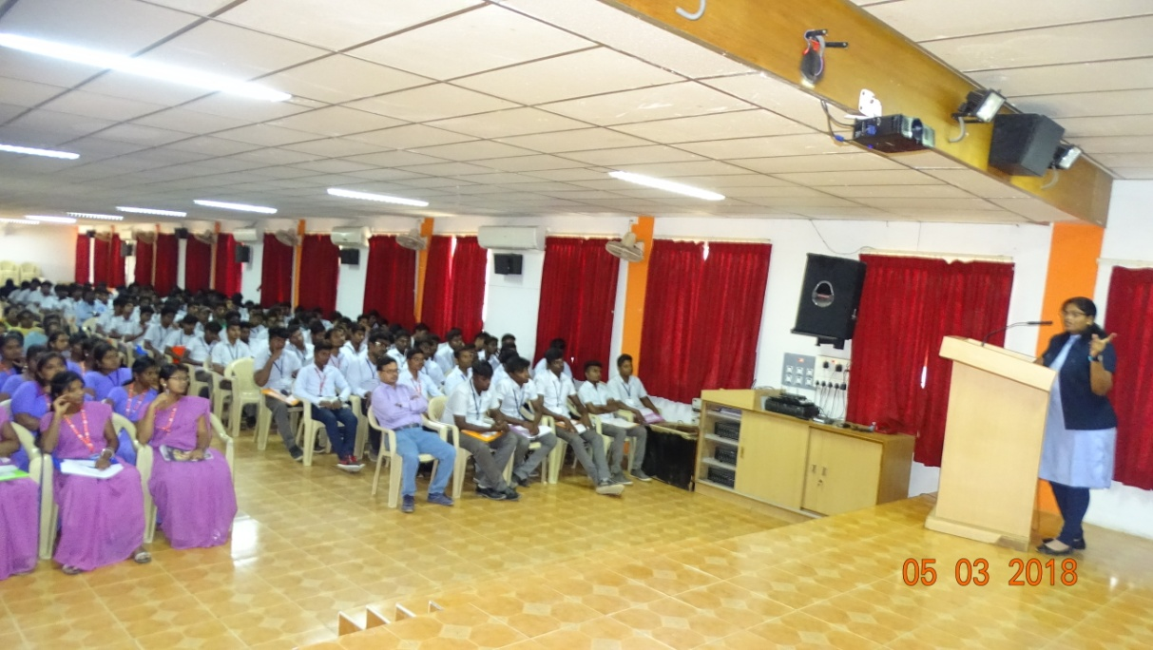

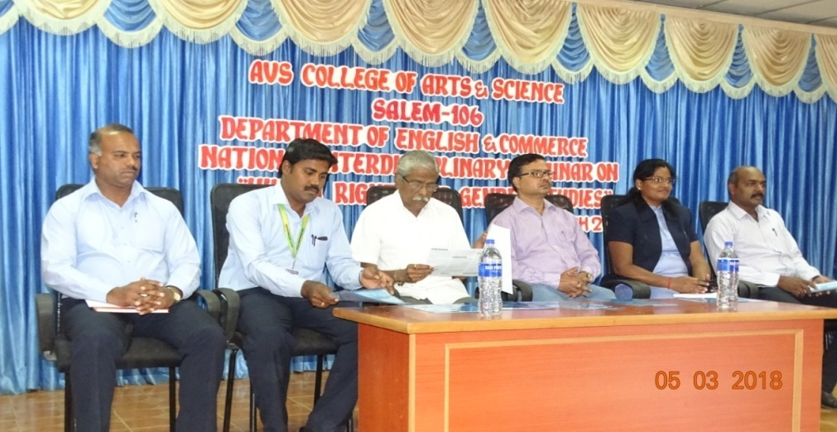

1. **“IMPACT OF GST ON MANUFACTURING SECTOR”** for the National Seminar on “GST- Perspectives of Indian Industries” organized by Department of Commerce, Siri PSG Arts and Science College for Women, Sankari , Salem on 27.02.2018.

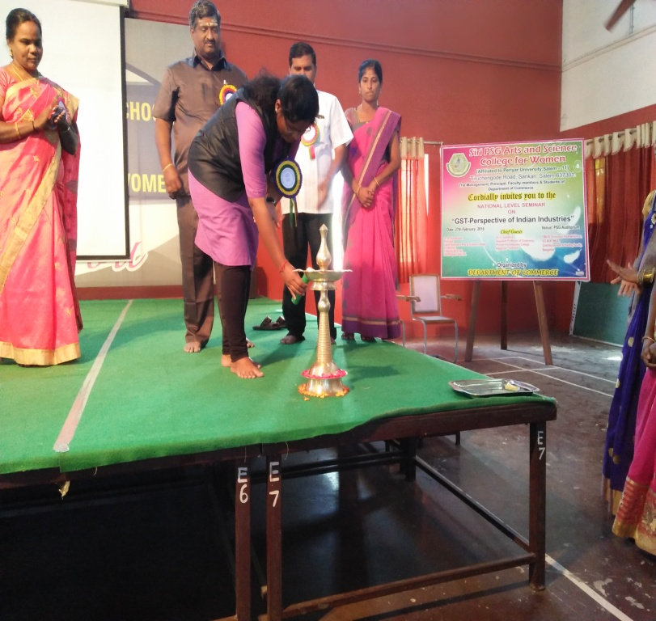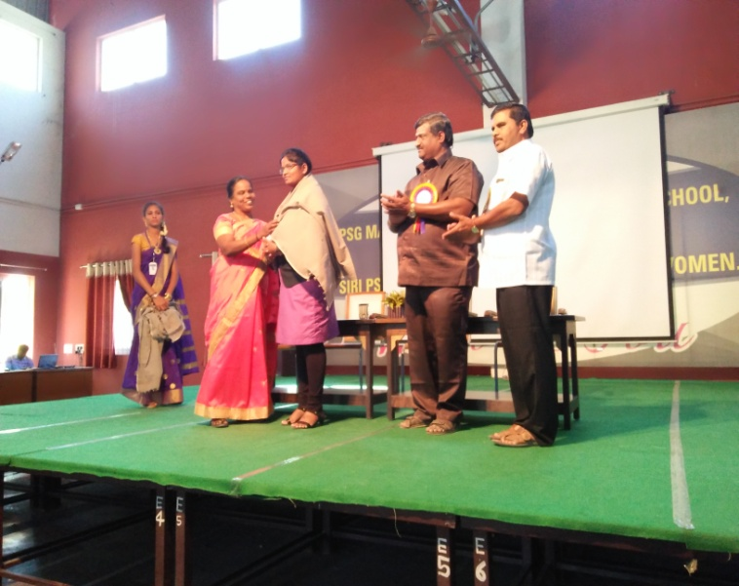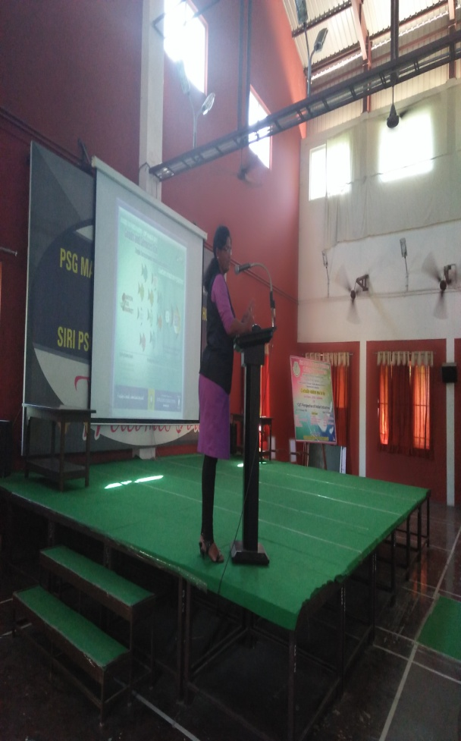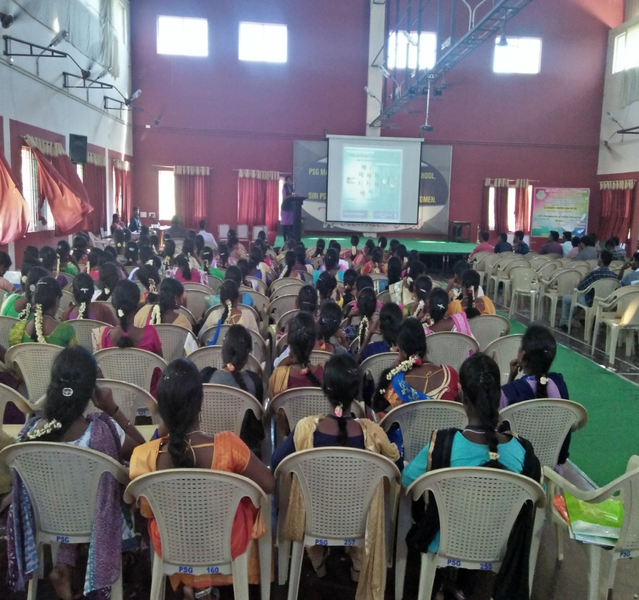

1. **“SOCIAL ENGINEERING”** Special Lecture for B.Com and M.Com students at Laxminarayana Arts and Science College for Women, Dharmapuri on 26.02.2018.

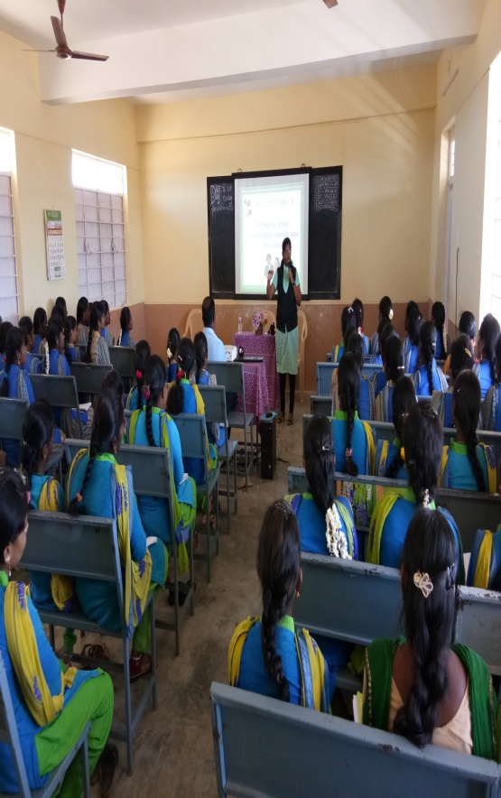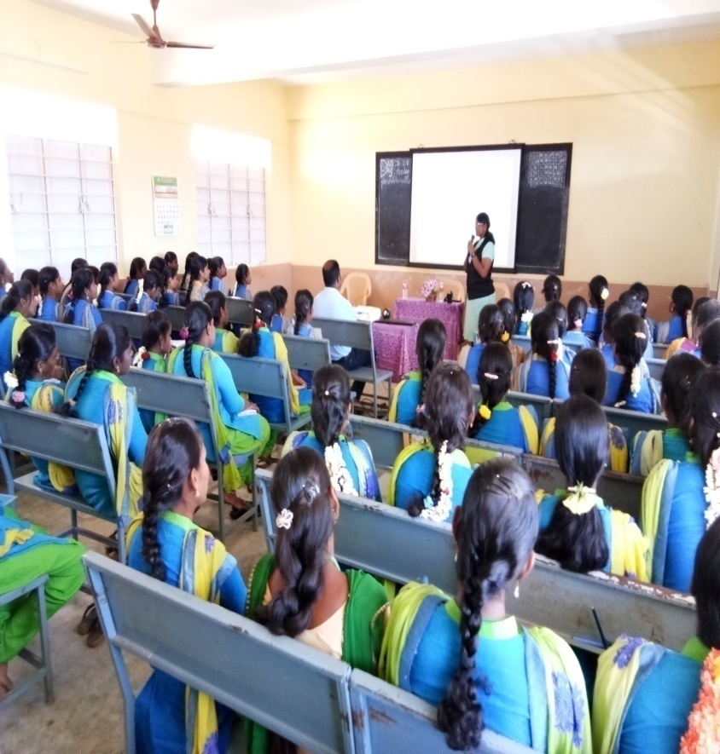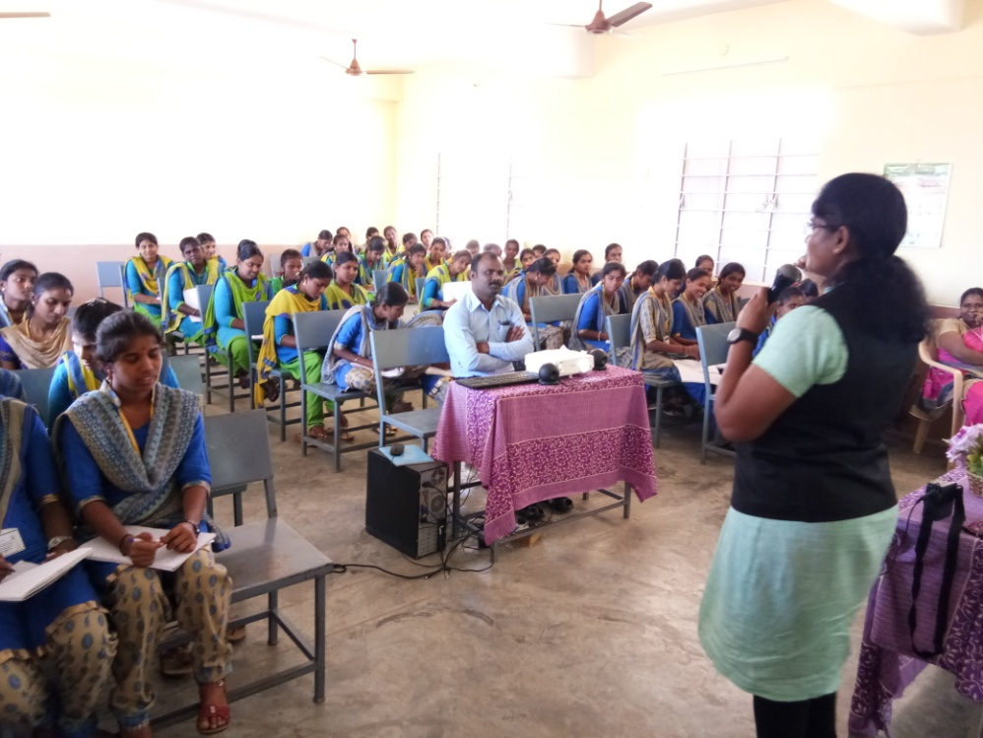

1. **“VOLUNTEERISM”** Guest Lecture for NSS Volunteers of Vivekanadha College, Agastheeswaram, during special camp on 20.02.2018.

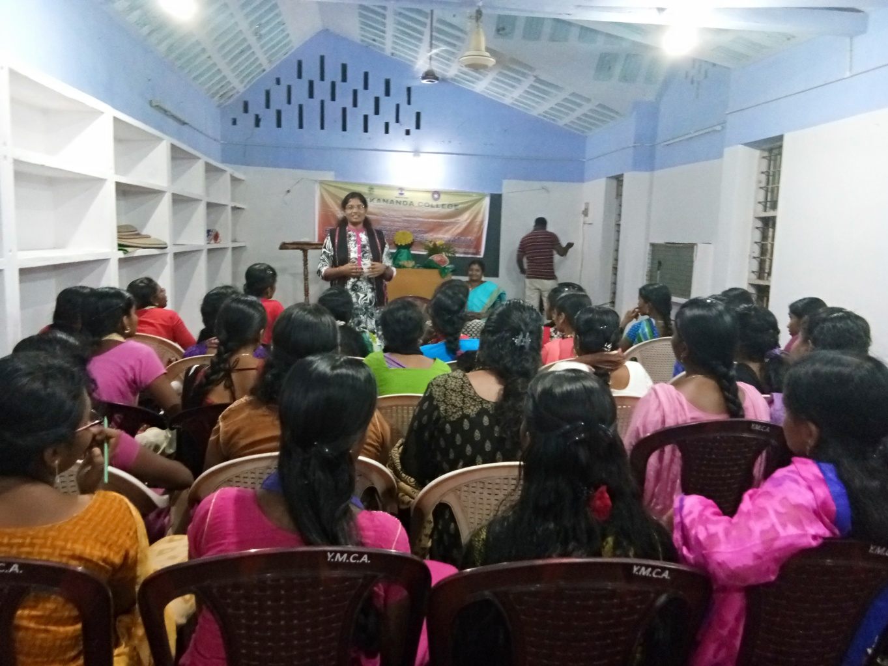

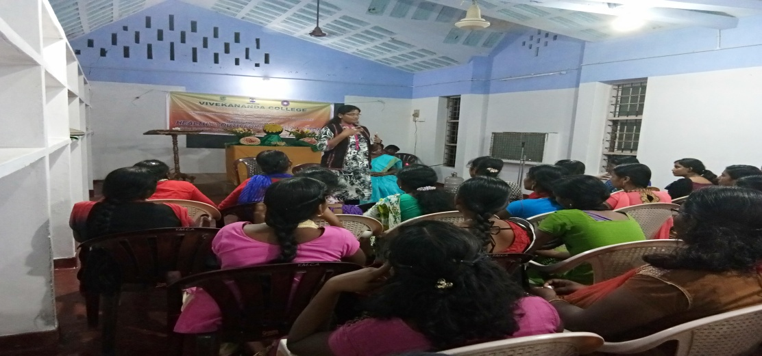

1. **“STATUS OF WOMEN IN CASHLESS ECONOMY”-** Resource person for the International Conference on organized by the PG Department of Commerce, KSR College of Arts and Science for Women, Thiruchengode, Namakkal, on 14th Sep 2017. (Delivered a presentation on Status of Women in Cashless Economy as a Resource Person )

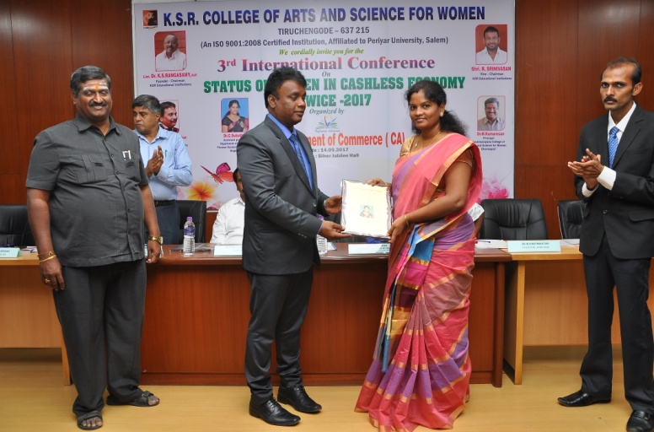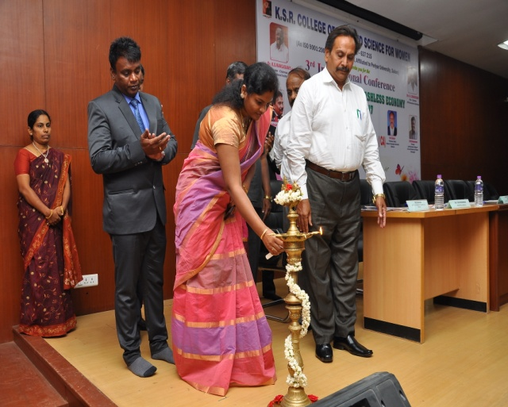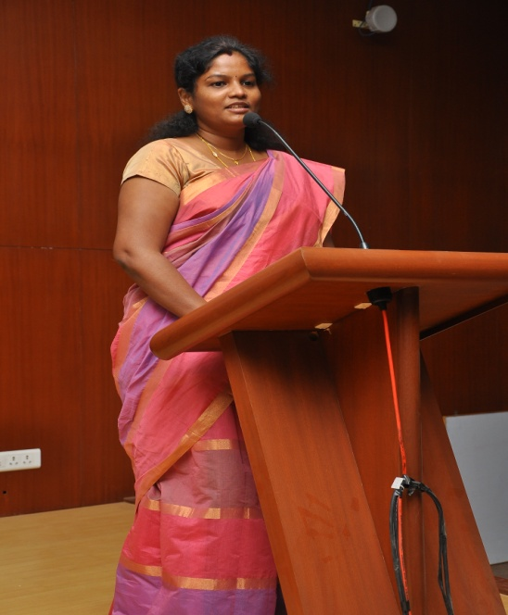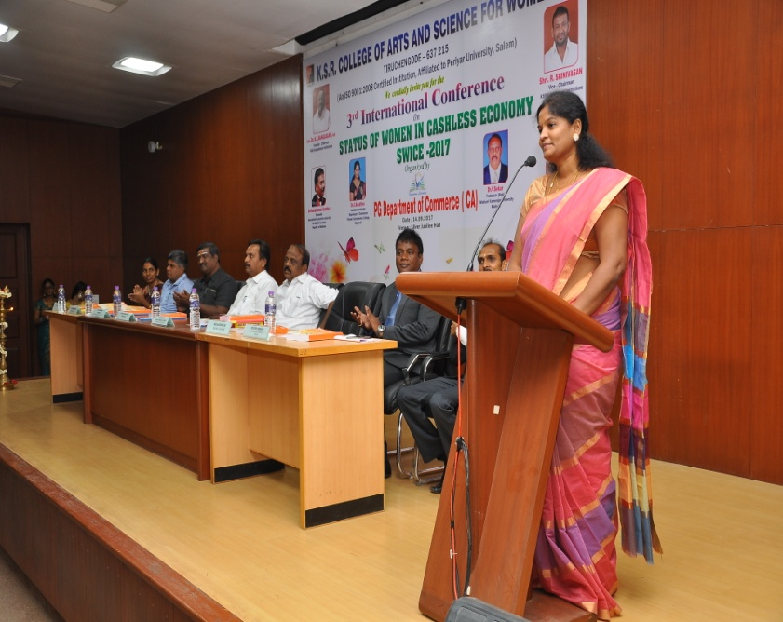

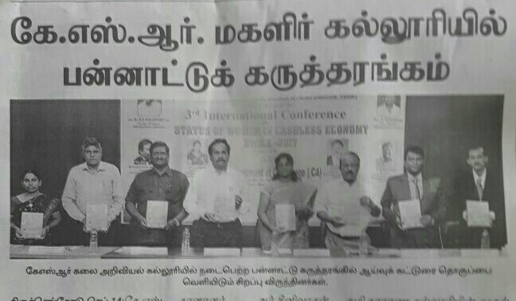

1. **“CONFLICT SOLVING”** Special Lecture at Sengundhar Arts and Science College, Tiruchengode for MBA Students on 15.09.2017.

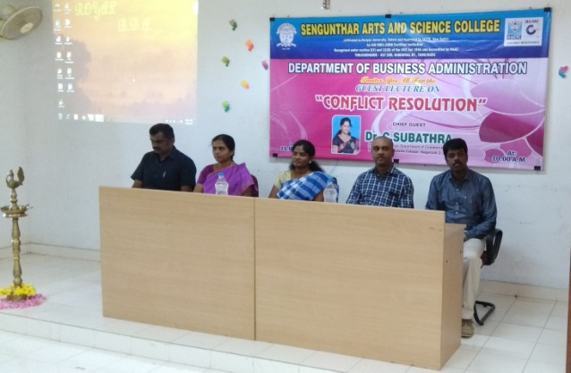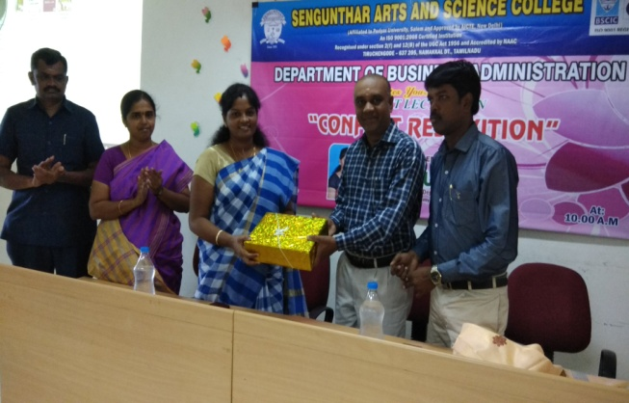

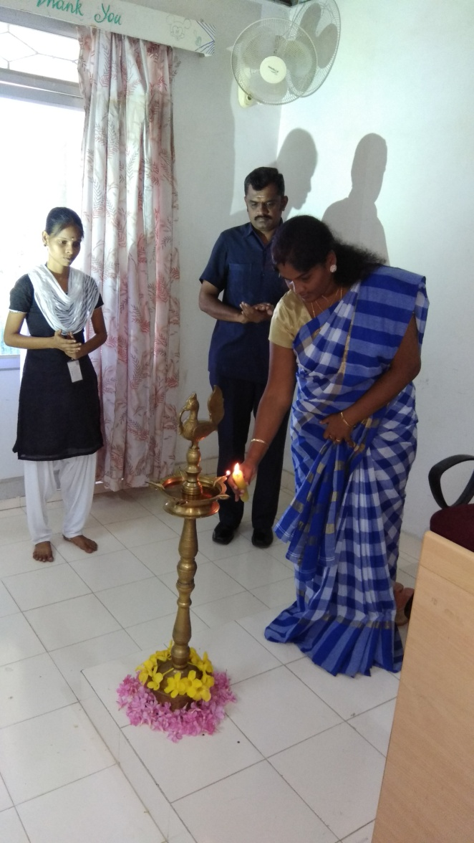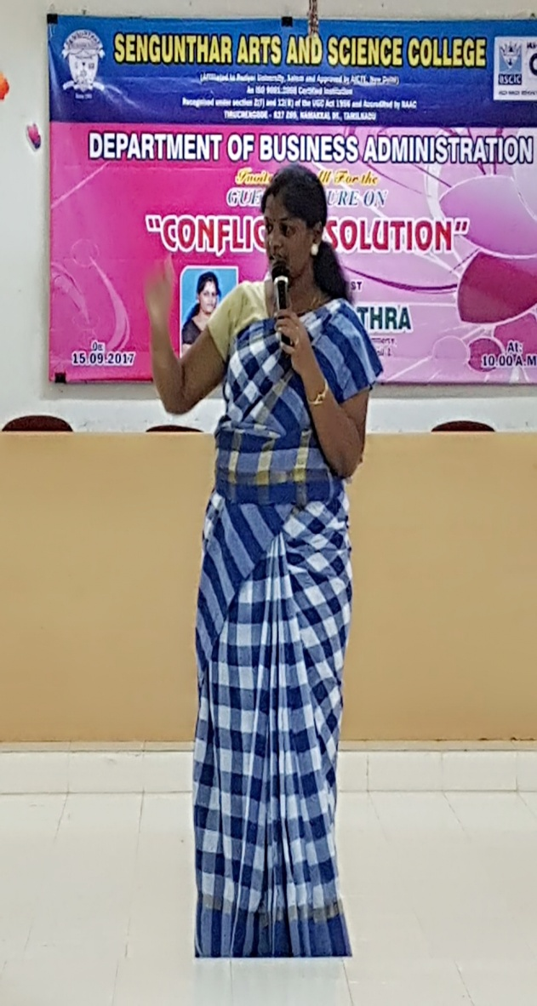

1. **“INDIAN CONSTITUTION - ROLE OF YOUTH”,** a talk and interactive session for the “Youth Camp” volunteers of Nehru Yuva Kendra Sangathan at Vivekananda Kendra, Kanyakumari on 17.09.2017.

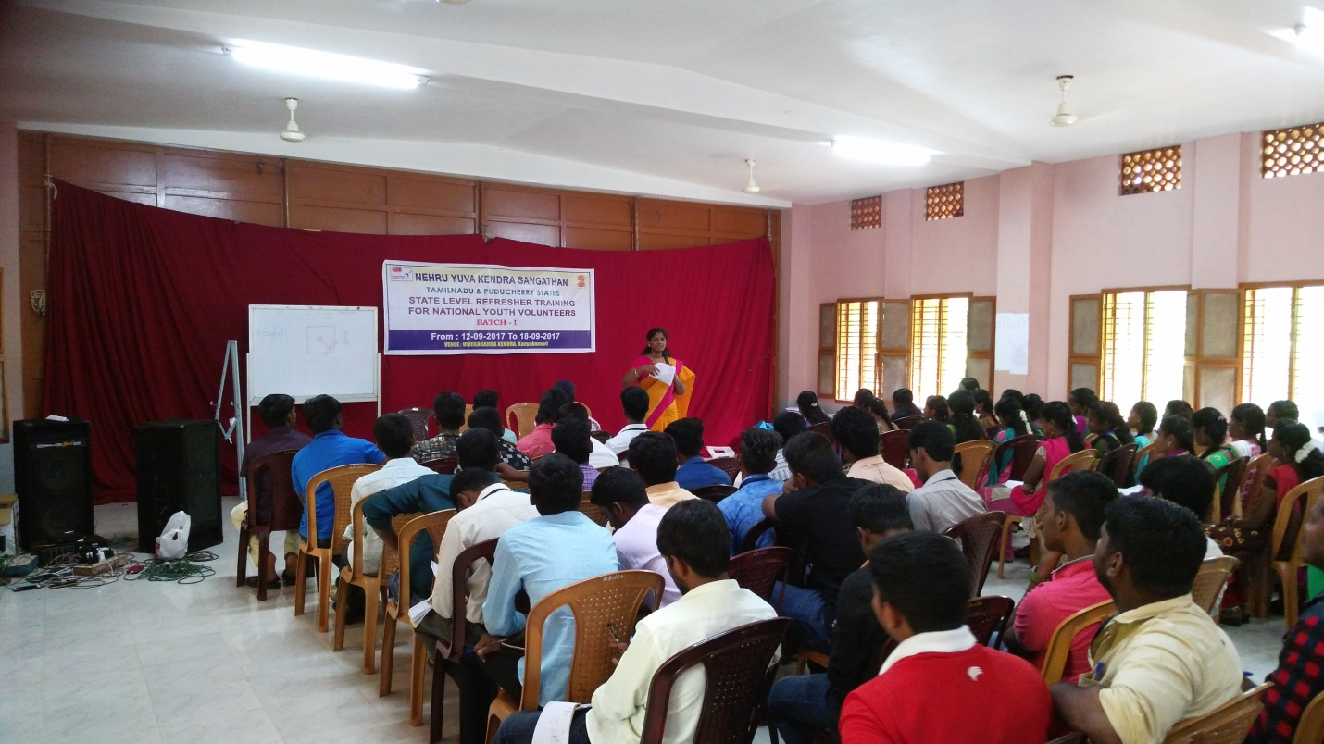

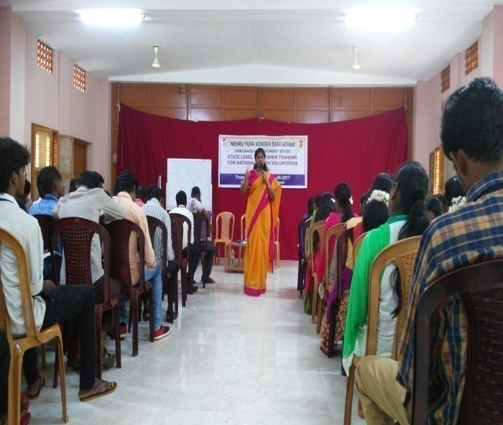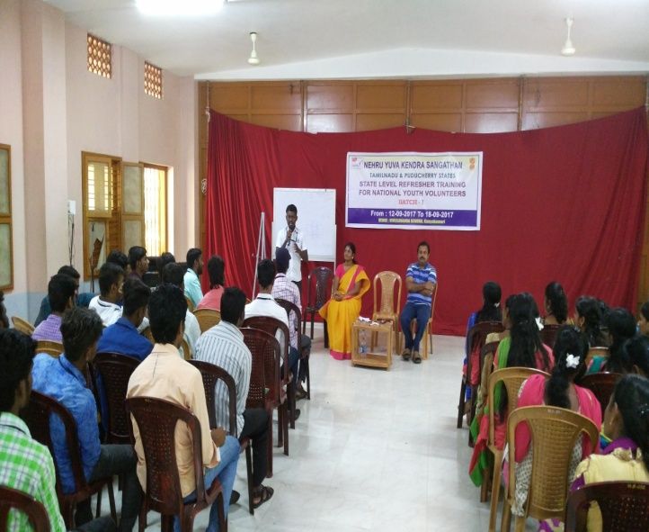

1. **“LEADERSHIP SKILL AND PERSONALITY DEVELOPMENT”,** a talk and interactive session for the “Youth Camp” volunteers of Nehru Yuva Kendra Sangathan at Vivekananda Kendra, Kanyakumari on 26.08.2017.

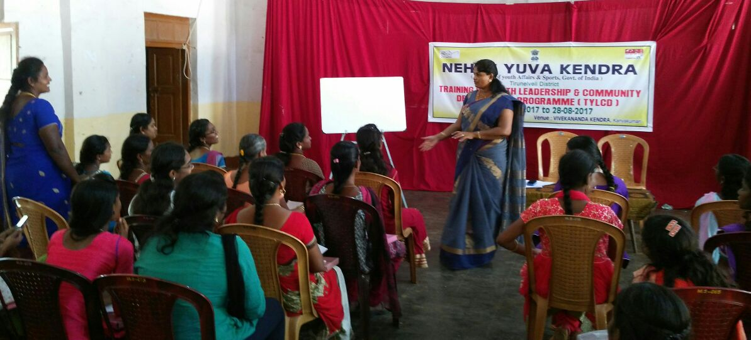

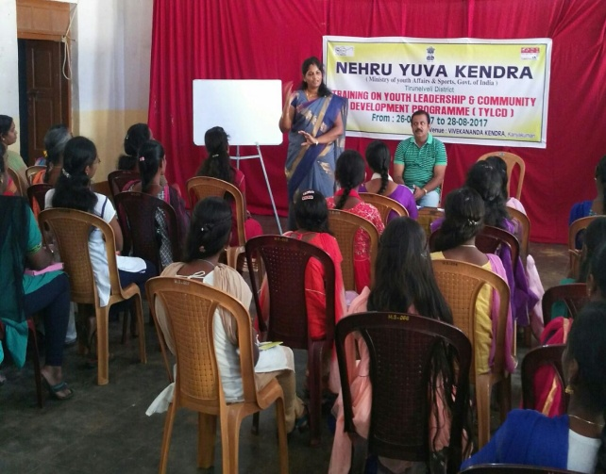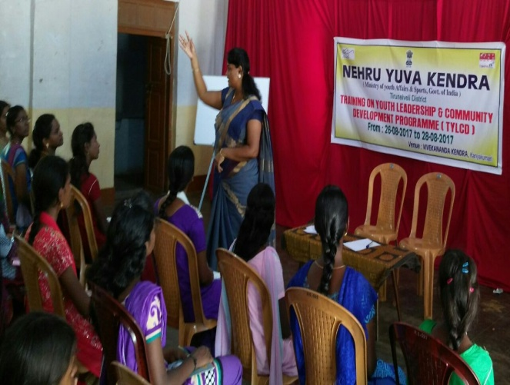

1. **“FINACIAL AWARENESS PROGRAM**” at DMI Engineering College, Aralvaimozhi, A technical session for ECE Final Year students on 28.07.2017.

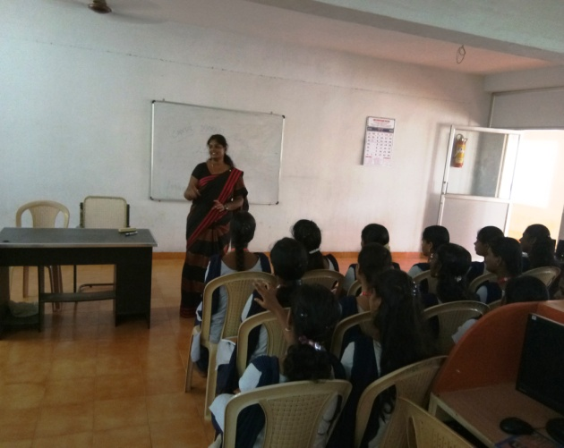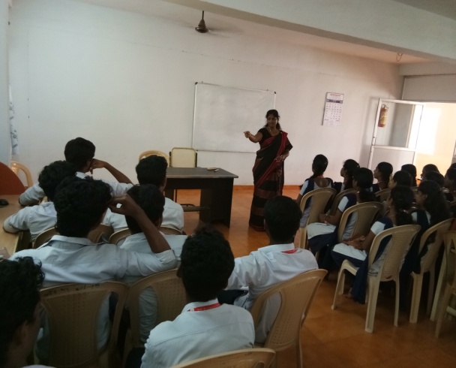

1. **“CONFLICT SOLVING”,** a technical session for the “Youth Camp” volunteers of Nehru Yuva Kendra Sangathan at Vivekananda Kendra, Kanyakumari on 13.06.2017.

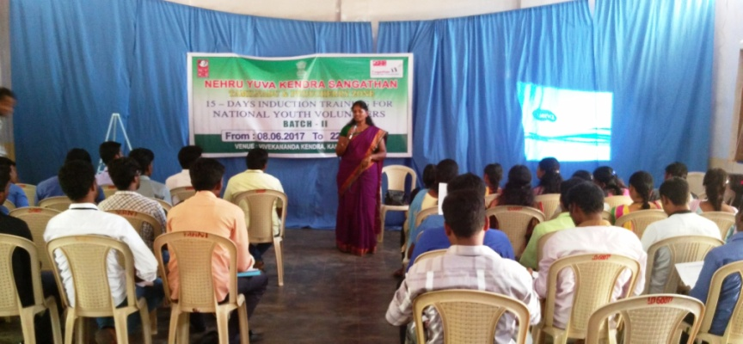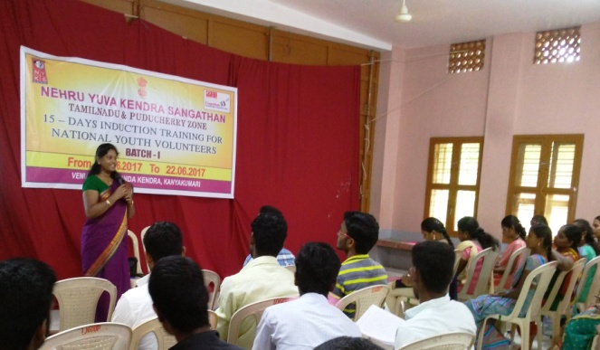

1. **“IMPERSONAL RELATIONSHIP: BUILD, SUSTAINING AND RESOLVE CONFLICT”,** a talk and interactive session for the “Youth Camp” volunteers of Nehru Yuva Kendra Sangathan at Vivekananda Kendra, Kanyakumari on 04.05.2017.

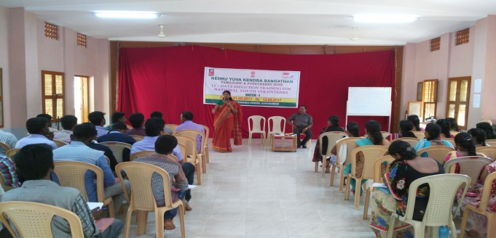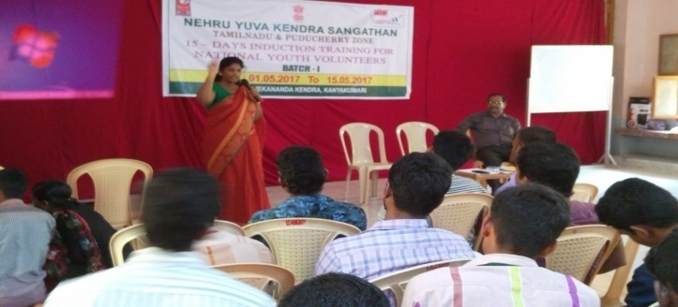

1. **“THE ROLE OF WOMEN AND IMPORTANCE OF WOMEN’S DAY”** for NSS Volunteers at Shri ayyappa College for Women, Chungankadai on 08.03.2017.

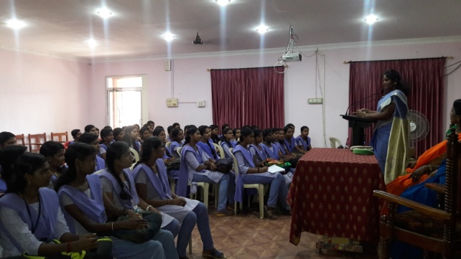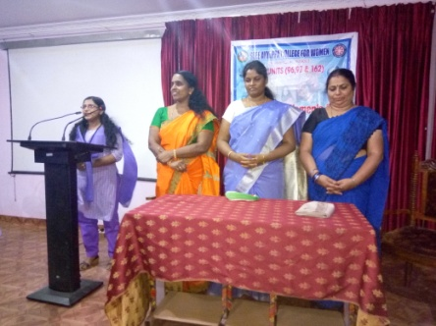

1. **“CLEAN INDIA – GREEN INDIA”** – A talk for NSS Volunteers on Mahatma ganthi Jayanthi T Pioneer Kumaraswamy College, Nagercoil on 02.10.2017.

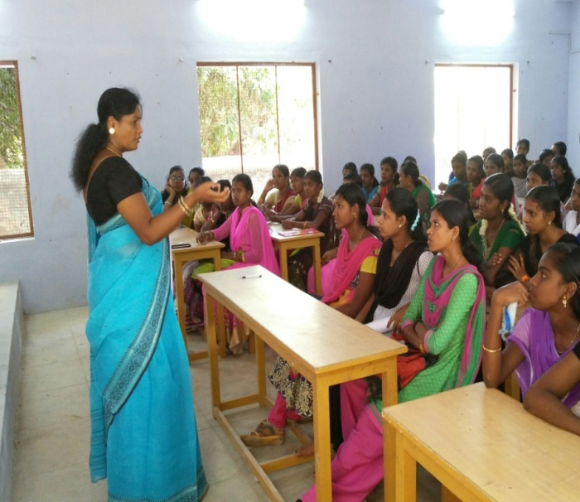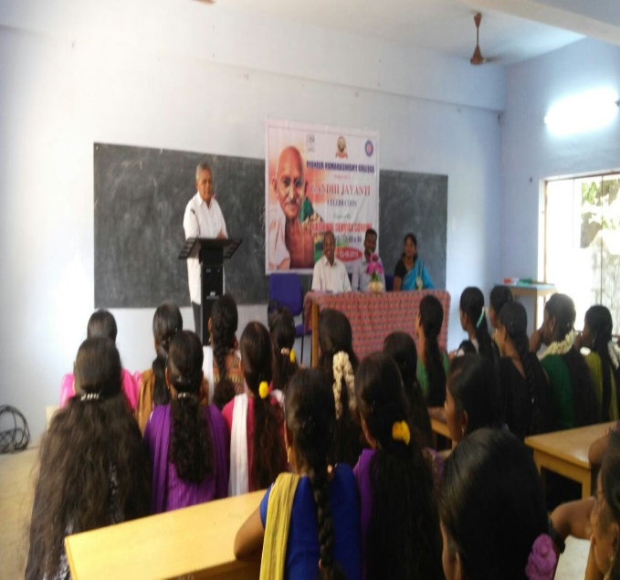

1. **“CAPITAL MARKET AWARENESS PROGRAM”** at Vins Christian College of Engineering, Chungankadai, Nagercoil, A technical session for MBA students on 23.09.2016.

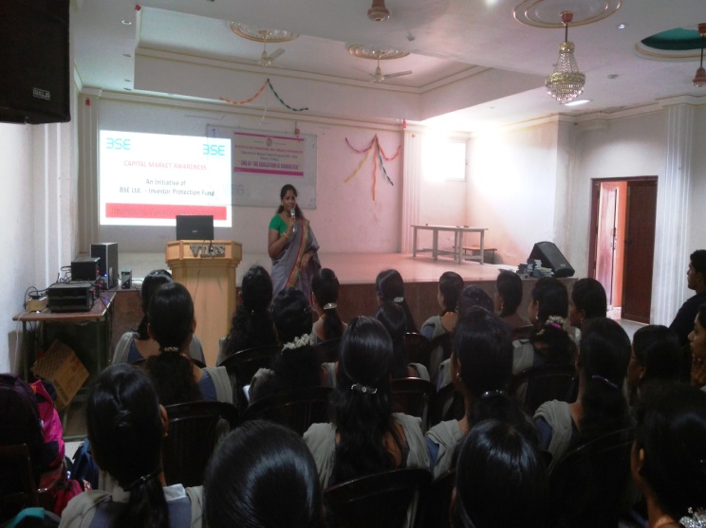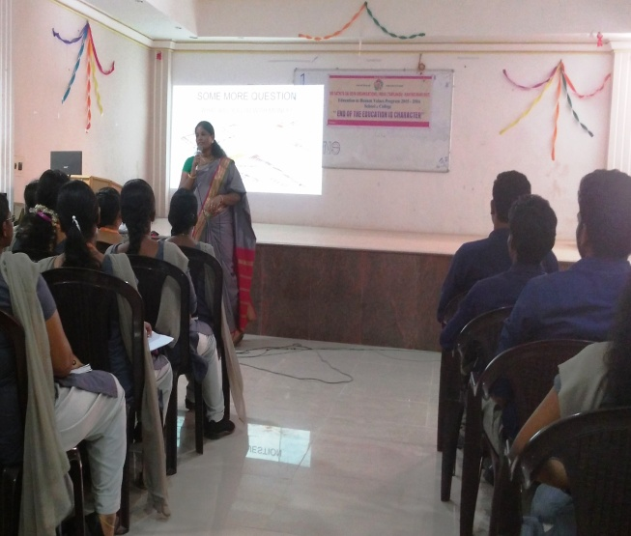

1. **“FINANCIAL LITERACY PROGRAM”** , at KNM Govt College of Arts and Science, Tiruvandhapuram for Commerce UG Students on 26.08.2016.

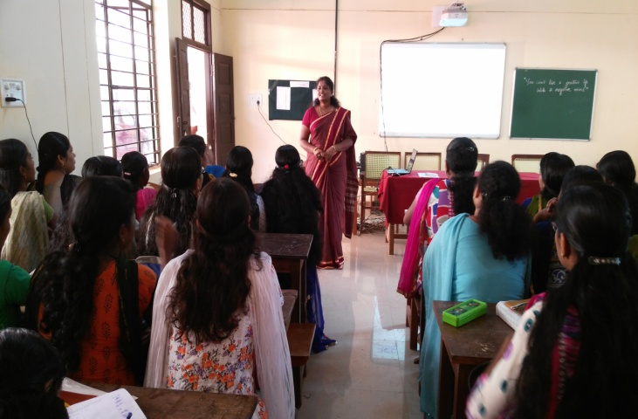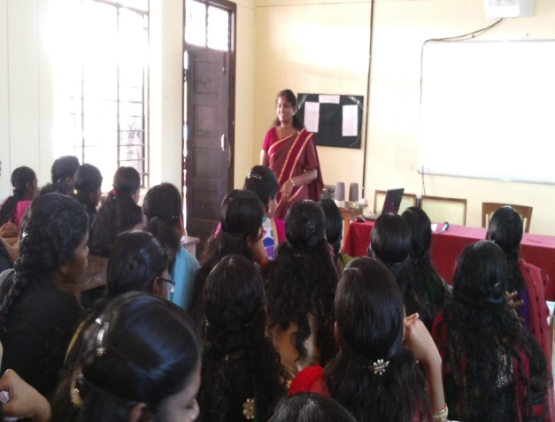

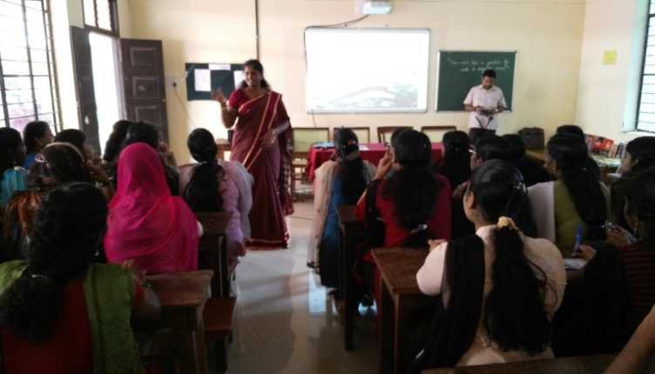

1. **“A GUIDELINES TO PREPARE NET EXAMINATION” (**Technical Session ) Commerce (P.G & M.Phil) students in Pioneer Kumaraswamy College, Nagercoil on 22.12.2014.

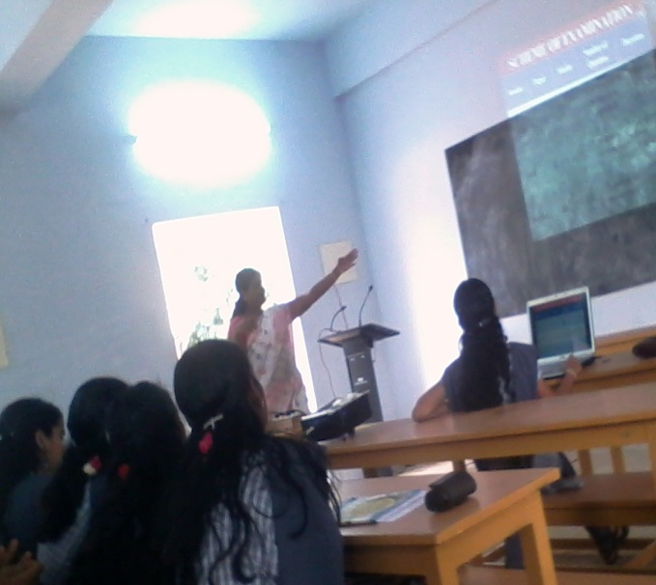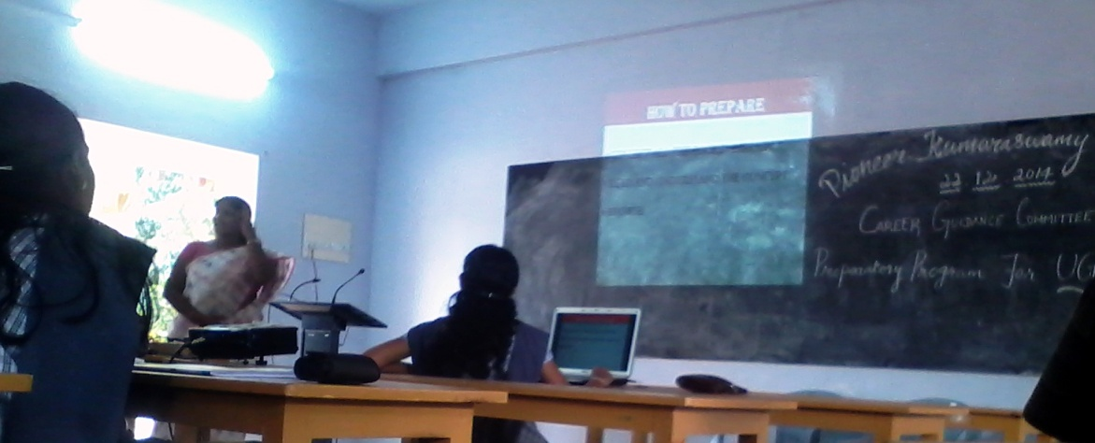

1. **“MANAGEMENT THOUGHTS”** (TECHNICAL SESSION) SCIENTIFIC AWARENESS CAMP FOR YOUNG SCIENTIST AT CSI Institute of Technology, Thovalai, on 9.11.2014.

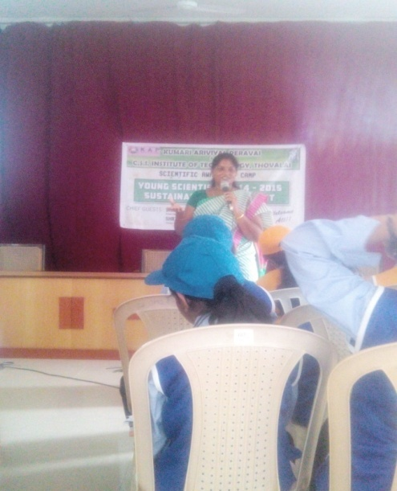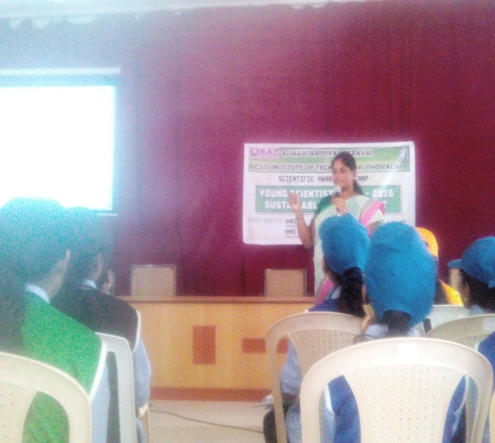

1. **“INTERIM UNION BUDGET - 2014”** (Technical Session) interdepartmental programme for Commerce and English at Pioneer Kumaraswamy College, Nagercoil, on 24.07.2014.

